Table of Contents

UNITED STATES

SECURITIES AND EXCHANGE COMMISSION
Washington, D.C. 20549

FORM 10-Q

- QUARTERLY REPORT PURSUANT TO SECTION 13 OR 15(d) OF THE SECURITIES EXCHANGE ACT OF 1934

For the Quarterly Period Ended June 30, 2019

or

- TRANSITION REPORT PURSUANT TO SECTION 13 OR 15(d) OF THE SECURITIES AND EXCHANGE ACT OF 1934

For the transition period from __________ to __________

Commission file number 001-34460

KRATOS DEFENSE & SECURITY SOLUTIONS, INC.

(Exact name of Registrant as specified in its charter)

Delaware

13-3818604

(State or other jurisdiction of

incorporation or organization)

(I.R.S. Employer Identification No.)

10680 Treena St., Suite 600

San Diego, CA 92131

(858) 812-7300
(Address, including zip code, and telephone number, including

area code, of registrant’s principal executive offices)

Securities registered pursuant to Section 12(b) of the Act:

Title of each class | Trading Symbol(s) | Name of each exchange on which registered
Common Stock, $0.001 par value | KTOS | The NASDAQ Global Select Market

Indicate by check mark whether the registrant (1) has filed all reports required to be filed by Section 13 or 15(d) of the Securities Exchange Act of 1934 during the preceding 12 months (or for such shorter period that the registrant was required to file such reports), and (2) has been subject to such filing requirements for the past 90 days. Yes ☒ No o

Indicate by check mark whether the registrant has submitted electronically every Interactive Data File required to be submitted pursuant to Rule 405 of Regulation S-T (Section 232.405 of this chapter) during the preceding 12 months (or for such shorter period that the registrant was required to submit such files). Yes ☒ No o

Indicate by check mark whether the registrant is a large accelerated filer, an accelerated filer, a non-accelerated filer, a smaller reporting company, or an emerging growth company. See the definitions of “large accelerated filer,” “accelerated filer,” “smaller reporting company,” and “emerging growth company” in Rule 12b-2 of the Exchange Act.

Large accelerated filer | ☒ | Accelerated filer | ☐
Non-accelerated filer | ☐ | Smaller reporting company | ☐
 |  | Emerging growth company | ☐

If an emerging growth company, indicate by check mark if the registrant has elected not to use the extended transition period for complying with any new or revised financial accounting standards provided pursuant to Section 13(a) of the Exchange Act. o

Indicate by check mark whether the registrant is a shell company (as defined in Rule 12b-2 of the Exchange Act). Yes ☐ No ☒ As of July 26, 2019, 106,104,642 shares of the registrant’s common stock were outstanding.

Table of Contents

KRATOS DEFENSE & SECURITY SOLUTIONS, INC.

FORM 10-Q

FOR THE QUARTERLY PERIOD ENDED JUNE 30, 2019

INDEX

 |  |  |  |  |  |  |  |  |  |  |  |  |  |  |  |  |  |  |  | Page
 |  |  |  |  |  |  |  |  |  |  | PART I. FINANCIAL INFORMATION
Item 1. |  |  | Financial Statements |  |  |  |  |  |  |  |  |  |  |  |  |  |  |  |  |  |  | 3
 |  |  | Condensed Consolidated Balance Sheets at June 30, 2019 and December 30, 2018 (unaudited) |  |  |  |  |  |  |  |  |  |  |  |  |  |  |  |  |  |  | 3
 |  |  | Condensed Consolidated Statements of Operations and Comprehensive Income (Loss) for the Three and Six Months Ended June 30, 2019 and July 1, 2018 (unaudited) |  |  |  |  |  |  |  |  |  |  |  |  |  |  |  |  | 4
 |  |  | Condensed Consolidated Statements of Stockholders’ Equity for the Three and Six Months Ended June 30, 2019 and July 1, 2018 (unaudited) |  |  |  |  |  |  |  |  |  |  |  |  |  |  |  |  |  |  | 5
 |  |  | Condensed Consolidated Statements of Cash Flows for the Six Months Ended June 30, 2019 and July 1, 2018 (unaudited) |  |  |  |  |  |  |  |  |  |  |  |  |  |  |  |  |  |  | 6
 |  |  | Notes to Condensed Consolidated Financial Statements (unaudited) |  |  |  |  |  |  |  |  |  |  |  |  |  |  |  |  |  |  | 7
Item 2. |  |  | Management’s Discussion and Analysis of Financial Condition and Results of Operations |  |  |  |  |  |  |  |  |  |  |  |  |  |  |  |  | 25
Item 3. |  |  | Quantitative and Qualitative Disclosures About Market Risk |  |  |  |  |  |  |  |  |  |  |  |  |  |  |  |  | 34
Item 4. |  |  | Controls and Procedures |  |  |  |  |  |  |  |  |  |  |  |  |  |  |  |  | 34
 |  |  |  |  |  |  |  |  |  |  |  | PART II. OTHER INFORMATION
Item 1. |  |  | Legal Proceedings |  |  |  |  |  |  |  |  |  |  |  |  |  |  |  |  | 36
Item 1A. |  |  | Risk Factors |  |  |  |  |  |  |  |  |  |  |  |  |  |  |  |  | 36
Item 2. |  |  | Unregistered Sales of Equity Securities and Use of Proceeds |  |  |  |  |  |  |  |  |  |  |  |  |  |  |  |  | 36
Item 3. |  |  | Defaults Upon Senior Securities |  |  |  |  |  |  |  |  |  |  |  |  |  |  |  |  | 36
Item 4. |  |  | Mine Safety Disclosures |  |  |  |  |  |  |  |  |  |  |  |  |  |  |  |  | 36
Item 5. |  |  | Other Information |  |  |  |  |  |  |  |  |  |  |  |  |  |  |  |  | 36
Item 6. |  |  | Exhibits |  |  |  |  |  |  |  |  |  |  |  |  |  |  |  |  | 37
 |  |  |  | 2

Table of Contents

PART I. FINANCIAL INFORMATION

Item 1. Financial Statements.

KRATOS DEFENSE & SECURITY SOLUTIONS, INC.

CONDENSED CONSOLIDATED BALANCE SHEETS

(in millions, except par value and number of shares)
 | June 30, 2019
 | (Unaudited) |  |  |  | December 30, 2018
Assets
Current assets:
Cash and cash equivalents | $ | 176.2 |  | $ | 182.7
Restricted cash |  | — |  |  | 0.3
Accounts receivable, net |  | 67.8 |  |  | 64.6
Unbilled receivables, net |  | 169.1 |  |  | 172.8
Inventoried costs |  | 75.4 |  |  | 46.8
Prepaid expenses |  | 10.3 |  |  | 8.9
Other current assets |  | 11.9 |  |  | 10.3
Current assets of discontinued operations |  | 5.3 |  |  | 8.3
Total current assets |  | 516.0 |  |  | 494.7
Property, plant and equipment, net |  | 115.5 |  |  | 67.1
Operating lease right-of-use assets |  | 43.8 |  |  | —
Goodwill |  | 459.4 |  |  | 425.7
Intangible assets, net |  | 32.4 |  |  | 16.1
Other assets |  | 6.5 |  |  | 6.5
Total assets | $ | 1,173.6 |  | $ | 1,010.1
Liabilities and Stockholders’ Equity
Current liabilities:
Accounts payable | $ | 52.7 |  | $ | 46.6
Accrued expenses |  | 39.2 |  |  | 38.1
Accrued compensation |  | 32.1 |  |  | 33.5
Accrued interest |  | 1.6 |  |  | 1.6
Billings in excess of costs and earnings on uncompleted contracts |  | 38.8 |  |  | 34.9
Current portion of operating lease liabilities |  | 12.1 |  |  | —
Other current liabilities |  | 8.9 |  |  | 4.7
Current liabilities of discontinued operations |  | 3.5 |  |  | 5.3
Total current liabilities |  | 188.9 |  |  | 164.7
Long-term debt principal, net of current portion |  | 294.6 |  |  | 294.2
Operating lease liabilities, net of current portion |  | 37.8 |  |  | —
Other long-term liabilities |  | 74.6 |  |  | 25.5
Long-term liabilities of discontinued operations |  | 2.8 |  |  | 6.4
Total liabilities |  | 598.7 |  |  | 490.8
Commitments and contingencies
Redeemable noncontrolling interest (Note 12) |  | 15.4 |  |  | —
Stockholders’ equity:
Preferred stock, $0.001 par value, 5,000,000 shares authorized, 0 shares outstanding at June 30, 2019 and December 30, 2018 |  | — |  |  | —
Common stock, $0.001 par value, 195,000,000 shares authorized; 105,914,292 and 103,766,899 shares issued and outstanding at June
30, 2019 and December 30, 2018, respectively |  | — |  |  | —
Additional paid-in capital |  | 1,277.8 |  |  | 1,244.5
Accumulated other comprehensive loss |  | (0.8) |  |  | (0.7)
Accumulated deficit |  | (717.5) |  |  | (724.5)
Total stockholders’ equity |  | 559.5 |  |  | 519.3
Total liabilities and stockholders’ equity | $ | 1,173.6 |  | $ | 1,010.1

The accompanying notes are an integral part of these condensed consolidated financial statements.

3

Table of Contents

KRATOS DEFENSE & SECURITY SOLUTIONS, INC.

CONDENSED CONSOLIDATED STATEMENTS OF OPERATIONS AND COMPREHENSIVE INCOME (LOSS)
(in millions, except per share amounts)
(Unaudited)

 |  | Three Months Ended |  |  |  |  |  | Six Months Ended
 |  | June 30, 2019 |  |  | July 1, 2018 |  |  | June 30, 2019 |  |  | July 1, 2018
Service revenues | $ | 73.7 |  | $ | 47.0 |  | $ | 136.3 |  | $ | 93.0
Product sales |  | 114.2 |  |  | 104.2 |  |  | 212.0 |  |  | 201.2
Total revenues |  | 187.9 |  |  | 151.2 |  |  | 348.3 |  |  | 294.2
Cost of service revenues |  | 50.6 |  |  | 33.2 |  |  | 92.6 |  |  | 66.1
Cost of product sales |  | 89.2 |  |  | 78.7 |  |  | 162.7 |  |  | 148.0
Total costs |  | 139.8 |  |  | 111.9 |  |  | 255.3 |  |  | 214.1
Gross profit |  | 48.1 |  |  | 39.3 |  |  | 93.0 |  |  | 80.1
Selling, general and administrative expenses |  | 33.7 |  |  | 30.1 |  |  | 65.2 |  |  | 59.9
Merger and acquisition expenses |  | 0.6 |  |  | — |  |  | 1.8 |  |  | —
Research and development expenses |  | 4.5 |  |  | 3.6 |  |  | 8.4 |  |  | 7.2
Restructuring expenses and other |  | 0.3 |  |  | 3.0 |  |  | 0.4 |  |  | 3.4
Operating income from continuing operations |  | 9.0 |  |  | 2.6 |  |  | 17.2 |  |  | 9.6
Other income (expense):
Interest expense, net |  | (5.3) |  |  | (5.7) |  |  | (10.8) |  |  | (10.8)
Other income (expense), net |  | 0.1 |  |  | (0.6) |  |  | (0.4) |  |  | (0.3)
Total other expense, net |  | (5.2) |  |  | (6.3) |  |  | (11.2) |  |  | (11.1)
Income (loss) from continuing operations before income taxes |  | 3.8 |  |  | (3.7) |  |  | 6.0 |  |  | (1.5)
Provision for income taxes from continuing operations |  | 2.5 |  |  | 0.1 |  |  | 1.0 |  |  | 1.0
Income (loss) from continuing operations |  | 1.3 |  |  | (3.8) |  |  | 5.0 |  |  | (2.5)
Discontinued operations
Income (loss) from operations of discontinued component |  | 2.9 |  |  | (5.7) |  |  | 2.4 |  |  | (9.6)
Income tax benefit |  | 0.1 |  |  | 1.8 |  |  | — |  |  | 2.2
Income (loss) from discontinued operations |  | 3.0 |  |  | (3.9) |  |  | 2.4 |  |  | (7.4)
Net income (loss) |  | 4.3 |  |  | (7.7) |  |  | 7.4 |  |  | (9.9)
Less: Net income attributable to noncontrolling interest |  | 0.4 |  |  | — |  |  | 0.4 |  |  | —
Net income (loss) attributable to Kratos | $ | 3.9 |  | $ | (7.7) |  | $ | 7.0 |  | $ | (9.9)
Basic income (loss) per common share attributable to Kratos:
Income (loss) from continuing operations | $ | 0.01 |  | $ | (0.04) |  | $ | 0.04 |  | $ | (0.02)
Income (loss) from discontinued operations |  | 0.03 |  |  | (0.03) |  |  | 0.02 |  |  | (0.08)
Net income (loss) per common share | $ | 0.04 |  | $ | (0.07) |  | $ | 0.06 |  | $ | (0.10)
Diluted income (loss) per common share attributable to Kratos:
Income (loss) from continuing operations | $ | 0.01 |  | $ | (0.04) |  | $ | 0.04 |  | $ | (0.02)
Income (loss) from discontinued operations |  | 0.03 |  |  | (0.03) |  |  | 0.02 |  |  | (0.08)
Net income (loss) per common share | $ | 0.04 |  | $ | (0.07) |  | $ | 0.06 |  | $ | (0.10)

Weighted average common shares outstanding:

Basic

Diluted

Comprehensive Income (Loss)

Net income (loss) (from above)

Change in cumulative translation adjustment

 | 106.1 |  |  | 103.7 |  |  | 105.5 |  |  | 103.7
 | 109.4 |  |  | 103.7 |  |  | 108.6 |  |  | 103.7
$ | 4.3 |  | $ | (7.7) |  | $ | 7.4 |  | $ | (9.9)
 | (0.1) |  |  | 0.1 |  |  | (0.1) |  |  | —

Comprehensive income (loss) |  | 4.2 |  |  | (7.6) |  |  | 7.3 |  |  | (9.9)
Less: Comprehensive income attributable to noncontrolling interest |  | 0.4 |  |  | — |  |  | 0.4 |  |  | —
Comprehensive income (loss) attributable to Kratos | $ | 3.8 |  | $ | (7.6) |  | $ | 6.9 |  | $ | (9.9)

The accompanying notes are an integral part of these condensed consolidated financial statements.

4

Table of Contents

KRATOS DEFENSE & SECURITY SOLUTIONS, INC.

CONDENSED CONSOLIDATED STATEMENTS OF STOCKHOLDERS’ EQUITY
(in millions)

(Unaudited)

 |  | Redeemable |  |  | Common Stock |  |  |  |  |  | Additional Paid-In |  |  | Accumulated Other |  |  |  |  |  | Total Stockholders’
 |  | Redeemable |  |  | Shares |  |  | Amounts |  |  |  |  |  |  |  | Accumulated Deficit |  |  |  | Total Stockholders’
 |  | Noncontrolling Interest |  |  | Shares |  |  | Amounts |  |  | Capital |  |  | Comprehensive Loss |  |  |  |  |  | Equity
Balance, December 31, 2017 | $ | — |  |  | 103.3 |  | $ | — |  | $ | 1,233.7 |  | $ | (1.4) |  | $ | (720.8) |  | $ | 511.5
Impact from the adoption of ASC 606 |  | — |  |  | — |  |  | — |  |  | — |  |  | — |  |  | (0.2) |  |  | (0.2)
Stock-based compensation |  | — |  |  | — |  |  | — |  |  | 1.7 |  |  | — |  |  | — |  |  | 1.7
Issuance of common stock for employee stock purchase |  |  |  |  |  |  |  | — |  |  |  |  |  | — |  |  | —
plan, options and warrants |  | — |  |  | 0.2 |  |  |  |  |  | 1.8 |  |  |  |  |  |  |  |  | 1.8
Net loss |  | — |  |  | — |  |  | — |  |  | — |  |  | — |  |  | (2.2) |  |  | (2.2)
Other comprehensive income (loss), net of tax |  | — |  |  | — |  |  | — |  |  | — |  |  | (0.1) |  |  | — |  |  | (0.1)
Balance April 1, 2018 | $ | — |  |  | 103.5 |  | $ | — |  | $ | 1,237.2 |  | $ | (1.5) |  | $ | (723.2) |  | $ | 512.5
Stock-based compensation |  | — |  |  | — |  |  | — |  |  | 1.7 |  |  | — |  |  | — |  |  | 1.7
Restricted stock issued and related taxes |  | — |  |  | — |  |  | — |  |  | (0.1) |  |  | — |  |  | — |  |  | (0.1)
Net loss |  | — |  |  | — |  |  | — |  |  | — |  |  | — |  |  | (7.7) |  |  | (7.7)
Other comprehensive income (loss), net of tax |  | — |  |  | — |  |  | — |  |  | — |  |  | 0.1 |  |  | — |  |  | 0.1
Balance, July 1, 2018 | $ | — |  |  | 103.5 |  | $ | — |  | $ | 1,238.8 |  | $ | (1.4) |  | $ | (730.9) |  | $ | 506.5
 |  | Redeemable |  |  | Common Stock |  |  |  |  |  | Additional Paid-In |  |  | Accumulated Other |  |  |  |  |  | Total Stockholders’
 |  | Redeemable |  |  | Shares |  |  | Amounts |  |  |  |  |  |  |  | Accumulated Deficit |  |  |  | Total Stockholders’
 |  | Noncontrolling Interest |  |  | Shares |  |  | Amounts |  |  | Capital |  |  | Comprehensive Loss |  |  |  |  |  | Equity
Balance, December 30, 2018 | $ | — |  |  | 103.8 |  | $ | — |  | $ | 1,244.5 |  | $ | (0.7) |  | $ | (724.5) |  | $ | 519.3
Stock-based compensation |  | — |  |  | — |  |  | — |  |  | 2.6 |  |  | — |  |  | — |  |  | 2.6
Issuance of common stock for employee stock purchase |  |  |  |  |  |  |  | — |  |  |  |  |  | — |  |  | —
plan, options and warrants |  | — |  |  | 0.2 |  |  |  |  |  | 1.7 |  |  |  |  |  |  |  |  | 1.7
Restricted stock issued and related taxes |  | — |  |  | 0.1 |  |  | — |  |  | (0.8) |  |  | — |  |  | — |  |  | (0.8)
Issuance of common stock for acquisitions |  | — |  |  | 1.8 |  |  | — |  |  | 27.0 |  |  | — |  |  | — |  |  | 27.0
Net income |  | — |  |  | — |  |  | — |  |  | — |  |  | — |  |  | 3.1 |  |  | 3.1
Other comprehensive income (loss), net of tax |  | — |  |  | — |  |  | — |  |  | — |  |  | — |  |  | — |  |  | —
Changes in noncontrolling interest |  | 15.0 |  |  | — |  |  | — |  |  | — |  |  | — |  |  | — |  |  | —
Balance, March 31, 2019 | $ | 15.0 |  |  | 105.9 |  | $ | — |  | $ | 1,275.0 |  | $ | (0.7) |  | $ | (721.4) |  | $ | 552.9
Stock-based compensation |  | — |  |  | — |  |  | — |  |  | 2.8 |  |  | — |  |  | — |  |  | 2.8
Net income |  | 0.4 |  |  | — |  |  | — |  |  | — |  |  | — |  |  | 3.9 |  |  | 3.9
Other comprehensive income (loss), net of tax |  | — |  |  | — |  |  | — |  |  | — |  |  | (0.1) |  |  | — |  |  | (0.1)
Balance, June 30, 2019 | $ | 15.4 |  |  | 105.9 |  | $ | — |  | $ | 1,277.8 |  | $ | (0.8) |  | $ | (717.5) |  | $ | 559.5

The accompanying notes are an integral part of these condensed consolidated financial statements.

5

Table of Contents

KRATOS DEFENSE & SECURITY SOLUTIONS, INC.

CONDENSED CONSOLIDATED STATEMENTS OF CASH FLOWS
(in millions)
(Unaudited)

 |  | Six Months Ended
 | June 30, 2019 |  |  |  | July 1, 2018
Operating activities:
Net income (loss) | $ | 7.4 |  | $ | (9.9)
Income (loss) from discontinued operations |  | 2.4 |  |  | (7.4)
Income (loss) from continuing operations |  | 5.0 |  |  | (2.5)
Adjustments to reconcile income (loss) from continuing operations to net cash provided by operating activities from continuing
operations:
Depreciation and amortization |  | 11.1 |  |  | 9.2
Amortization of lease right-of-use assets |  | 5.4 |  |  | —
Stock-based compensation |  | 5.4 |  |  | 3.4
Deferred income taxes |  | (3.1) |  |  | (0.7)
Amortization of deferred financing costs |  | 0.5 |  |  | 0.5
Changes in assets and liabilities, net of acquisitions:
Accounts receivable |  | 4.4 |  |  | 8.1
Unbilled receivables |  | 8.6 |  |  | (23.7)
Inventoried costs |  | (16.3) |  |  | 0.5
Prepaid expenses and other assets |  | (0.4) |  |  | 3.2
Operating lease liabilities |  | 0.8 |  |  | —
Accounts payable |  | 3.6 |  |  | 6.0
Accrued expenses |  | — |  |  | (1.4)
Accrued compensation |  | (2.1) |  |  | 3.9
Advance payments received on contracts |  | 0.1 |  |  | (0.6)
Billings in excess of costs and earnings on uncompleted contracts |  | 2.0 |  |  | (8.9)
Income tax receivable and payable |  | 1.2 |  |  | (1.0)
Other liabilities |  | (6.2) |  |  | 5.4
Net cash provided by operating activities from continuing operations |  | 20.0 |  |  | 1.4
Investing activities:
Cash paid for acquisitions, net of cash acquired |  | (17.6) |  |  | —
Capital expenditures |  | (9.8) |  |  | (11.0)
Proceeds from sale of assets |  | — |  |  | 67.9
Net cash provided by (used in) investing activities from continuing operations |  | (27.4) |  |  | 56.9
Financing activities:
Debt issuance costs |  | — |  |  | (0.1)
Expenses from the issuance of common stock |  | — |  |  | (1.1)
Repayment of debt |  | — |  |  | (0.5)
Payments under finance leases |  | (0.2) |  |  | —
Proceeds from exercise of restricted stock units, employee stock options, and employee stock purchase plan |  | 0.9 |  |  | 1.8
Net cash provided by financing activities from continuing operations |  | 0.7 |  |  | 0.1
Net cash flows of continuing operations |  | (6.7) |  |  | 58.4
Net operating cash flows of discontinued operations |  | — |  |  | (6.1)
Effect of exchange rate changes on cash, cash equivalents and restricted cash |  | (0.1) |  |  | (0.1)
Net increase (decrease) in cash, cash equivalents and restricted cash |  | (6.8) |  |  | 52.2
Cash, cash equivalents and restricted cash at beginning of period |  | 183.0 |  |  | 130.9
Cash, cash equivalents and restricted cash at end of period | $ | 176.2 |  | $ | 183.1

The accompanying notes are an integral part of these condensed consolidated financial statements.

6

Table of Contents

KRATOS DEFENSE & SECURITY SOLUTIONS, INC.

NOTES TO CONDENSED CONSOLIDATED FINANCIAL STATEMENTS

(Unaudited)

Note 1. Summary of Significant Accounting Policies

All references to the “Company” and “Kratos” refer to Kratos Defense & Security Solutions, Inc., a Delaware corporation, and its subsidiaries.

- Basis of Presentation

The information as of June 30, 2019 and for the three and six months ended June 30, 2019 and July 1, 2018 is unaudited. The condensed consolidated balance sheet as of December 30, 2018 was derived from the Company’s audited consolidated financial statements at that date. In the opinion of management, these unaudited condensed consolidated financial statements include all adjustments, consisting of normal recurring adjustments necessary for a fair presentation of the Company’s financial position, results of operations and cash flows for the interim periods presented. The results have been prepared in accordance with the instructions to Form 10-Q and do not necessarily include all information and footnotes necessary for presentation in accordance with accounting principles generally accepted in the U.S. (“GAAP”). These unaudited condensed consolidated financial statements should be read in conjunction with the consolidated financial statements and the related notes included in the Company’s audited annual consolidated financial statements for the fiscal year ended December 30, 2018, included in the Company’s Annual Report on Form 10-K filed with the U.S. Securities and Exchange Commission (the “SEC”) on February 28, 2019 (the “Form 10-K”). Interim operating results are not necessarily indicative of operating results expected in subsequent periods or for the year as a whole.

As discussed in “Acquisition” in Note 2, on February 27, 2019, the Company acquired 80.1% of the issued and outstanding shares of capital stock of Florida Turbine Technologies, Inc. (“FTT Inc.”), and 80.1% of the membership interests in FTT CORE, LLC (“FTT Core” and, together with FTT Inc.,“FTT”), for an aggregate purchase price of approximately $60 million. FTT is now the Kratos Turbine Technologies Division (the “KTT Division”), which is focused on the development and production of small, affordable, high-performance, jet engines for the next generation of tactical weapon systems and tactical jet unmanned aerial systems (“UAS”). The KTT Division is included in the Kratos Government Solutions (“KGS”) Segment.

- Principles of Consolidation

The condensed consolidated financial statements include the accounts of the Company, its 100% owned subsidiaries and its majority owned subsidiaries, FTT Inc. and FTT Core, each of which is 80.1% owned. All inter-company transactions have been eliminated in consolidation. Noncontrolling interest consists of the remaining 19.9% interest in FTT Inc. and FTT Core. See Note 12 for further information related to the redeemable noncontrolling interest.

- Fiscal Year

The Company has a 52/53 week fiscal year ending on the last Sunday of the calendar year. The three and six month periods ended June 30, 2019 and July 1, 2018 consisted of 13-week periods. There are 52 calendar weeks in the fiscal years ending on December 29, 2019 and December 30, 2018.

(d) Accounting Estimates

There have been no significant changes in the Company’s accounting estimates for the six months ended June 30, 2019 as compared to the accounting estimates described in the Form 10-K.

7

Table of Contents

(e) Accounting Standards Updates

In February 2016, the FASB issued ASU 2016-02 (“ASU 2016-02”), Leases, also referred to as “ASC 842”. ASU 2016-02 requires that lessees recognize assets and liabilities for the rights and obligations underlying leases with a lease term of more than one year. The amendments in this ASU are effective for annual periods beginning after December 15, 2018. In July 2018, the FASB issued ASU 2018-11, Leases; Targeted Improvements, which, among other things, allows a company to elect an optional transition method that applies the new lease requirements through a cumulative-effect adjustment in the period of adoption. The Company adopted this standard on December 31, 2018 using the optional transition method, and, as a result, did not recast prior period unaudited condensed comparative financial statements. All prior period amounts and disclosures are presented under Accounting Standards Codification Topic 840, Leases (“ASC 840”).

The Company has revised its controls and processes to address the new lease standard and has completed the implementation and data input for our lease accounting software tool. The Company has elected the package of practical expedients, which, among other things, allows carry-forward of prior lease classifications under the prior standard. However, the Company has not elected to adopt the hindsight practical expedient and is therefore maintaining the lease terms previously determined under the prior lease standard. For all new and modified leases after adoption of the ASU, the Company has taken the component election allowing the Company to account for lease components together with non-lease components in the calculation of the lease asset and corresponding liability. Adoption of the new standard resulted in the recording of additional lease assets and lease liabilities on the unaudited condensed consolidated balance sheet. No cumulative-effect adjustment was recognized as the amount was not material, and the impact on the Company’s results of operations and cash flows was also not material. See Note 8 for additional disclosures.

In February 2018, the FASB issued ASU 2018-02 (“ASU 2018-02”), Reclassification of Certain Tax Effects from Accumulated Other Comprehensive Income (“AOCI”). ASU 2018-02 provides entities the option to reclassify tax effects to retained earnings from AOCI which are impacted by the Tax Cuts and Jobs Act (“TCJA”). This ASU is effective for fiscal years beginning after December 15, 2018 but early adoption is permitted. The Company adopted this standard on December 31, 2018. The Company has a full valuation allowance for all tax benefits related to AOCI, and therefore, there are no tax effects to be reclassified to retained earnings.

- Fair Value of Financial Instruments

The carrying amounts and the related estimated fair values of the Company’s long-term debt financial instruments not measured at fair value on a recurring basis at June 30, 2019 and December 30, 2018 are presented in Note 10. The carrying value of all other financial instruments, including cash equivalents, accounts receivable, accounts payable, accrued expenses, billings in excess of cost and earnings on uncompleted contracts, income taxes payable and short-term debt, approximated their estimated fair values at June 30, 2019 and December 30, 2018 due to the short-term nature of these instruments.

Note 2. Acquisition

On February 27, 2019, the Company acquired 80.1% of the issued and outstanding shares of capital stock of FTT Inc., and 80.1% of the membership interests in FTT Core for an aggregate purchase price of approximately $60 million. The purchase price was $33 million in cash, with approximately $17.7 million paid at close and approximately $15.3 million to be paid over a three-year period, subject to adjustments for transaction expenses, indebtedness, cash on hand, certain amounts payable or potentially payable to employees of FTT and post-closing working capital adjustments, and 1,825,406 shares of common stock (with a value of approximately $27 million).

FTT is a leading turbomachinery design and manufacturing company specializing in engineering, development, and testing of gas turbines, propulsion components, and systems for military and commercial applications. FTT is now the KTT Division, which is focused on the development and production of small, affordable, high-performance, jet engines for the next generation of tactical weapon systems and tactical jet UAS. The KTT Division is included in the KGS Segment.

The excess of the purchase price over the fair value of the tangible and identifiable intangible assets acquired and liabilities assumed in the acquisition was allocated to goodwill. The goodwill represents the value the Company expects to be created by enabling it to accelerate FTT’s small engine development programs, and facilitate integration of these leading-edge engine solutions with evolving Kratos tactical systems.

Simultaneously with the execution of the Purchase Agreement among the Company and the Sellers (as defined in such agreement) (the “Purchase Agreement”) and completion of the acquisition, the Company, FTT Inc., FTT Core and the Sellers

8

Table of Contents

entered into an exchange agreement (the “Exchange Agreement”) pursuant to which, among other things, (i) FTT Core was converted into a Delaware corporation, (ii) beginning in January 2024, the Holders (as defined in the Exchange Agreement) will have an annual right (the “Put Right”) to sell all of the minority interests in FTT Inc. and FTT Core (the “Minority Interests”) to the Company at a purchase price based on an assumed enterprise value of 12 times the trailing 12 months EBITDA of FTT Inc., FTT Core and each of their respective subsidiaries (the “Acquired Companies”), subject to adjustment as set forth in the Exchange Agreement (the “Minority Interest Purchase Price”) (provided, however, that following certain events, including a change of control, the Put Right will be accelerated and the Minority Interest Purchase Price will be increased to 14 times the trailing 12 months EBITDA of the Acquired Companies), and (iii) beginning in January 2025, the Company will have an annual right to purchase all of the Minority Interests from the Holders at the Minority Interest Purchase Price.

The transaction has been accounted for using the acquisition method of accounting, which requires, among other things, that the assets acquired, the liabilities assumed, and the noncontrolling interest be recognized at their fair values as of the acquisition date. The fair value measurements are based primarily on significant inputs not observable in the marketplace and thus represent Level 3 measurements. The following table summarizes the provisional allocation of the purchase price over the estimated fair values of the major assets acquired, liabilities assumed, and noncontrolling interest (in millions):

Accounts receivable | $ | 7.3
Unbilled receivables |  | 4.9
Inventoried costs |  | 11.7
Other current assets |  | 1.3
Property and equipment |  | 9.7
Intangible assets |  | 19.8
Goodwill |  | 29.3
Total identifiable net assets acquired |  | 84.0
Total identifiable net liabilities assumed |  | (9.0)
Net assets before noncontrolling interest |  | 75.0
Noncontrolling interest |  | (15.0)
Net assets acquired, excluding cash | $ | 60.0

As of February 27, 2019, net liabilities include $7.7 million of current liabilities and $1.3 million of long-term liabilities. There was no contingent purchase consideration associated with the acquisition of an 80.1% majority interest in FTT. The amounts above represent the provisional fair value estimates as of March 31, 2019 and are subject to subsequent adjustment as the Company obtains additional information during the measurement period and finalizes its fair value estimates. If an adjustment to the provisional amounts recognized is subsequently identified during the measurement period, the Company will recognize the adjustment in the reporting period in which the adjustment amount is determined, including recording cumulative catch-up changes to depreciation, amortization, or other income statement effects recognized in completing the initial accounting. The provisional identifiable intangible asset estimates include customer relationships of $11.2 million with a useful life of 10 years, in-process research and development of $6.0 million that will commence amortization at the completion of the development project, backlog of $2.2 million with a useful life of 2 years, and trade name of $0.4 million with a useful life of 1 year. Any subsequent adjustments to these fair value estimates occurring during the measurement period will result in an adjustment to goodwill. The Company also established a deferred tax liability of $4.4 million for the increase in the financial statement basis of the acquired assets of FTT and a corresponding increase in goodwill. The goodwill recorded in this transaction is not expected to be tax-deductible.

The amounts of revenue and operating income of FTT included in the Company's condensed consolidated statement of operations for the three months ended June 30, 2019 are $17.2 million and $1.6 million, respectively. The amounts of revenue and operating income of FTT included in the Company's condensed consolidated statement of operations for the six months ended June 30, 2019 are $21.4 million and $1.7 million, respectively. Included in the merger and acquisition expenses, for the three and six months ended June 30, 2019 are transaction expenses of $0.1 million and $1.3 million, respectively, related to the acquisition of FTT.

9

Table of Contents
A summary of the consideration paid for the acquired ownership in FTT is as follow:
Cash paid |  | $ | 20.7
Deferred purchase consideration |  |  | 15.3
Common stock issued |  |  | 27.0
 |  |  | 63.0
Less: Cash acquired |  |  | (3.0)
Total consideration |  | $ | 60.0

Pro Forma Financial Information

The following tables summarize the supplemental condensed consolidated statements of operations information on an unaudited pro forma basis as if the acquisition of FTT occurred on December 31, 2018 and include adjustments that were directly attributable to the foregoing transactions. There are no material, nonrecurring pro forma adjustments directly attributable to the business combination included in the reported pro forma revenue and earnings. The pro forma results are for illustrative purposes only for the applicable period and do not purport to be indicative of the actual results that would have occurred had the transaction been completed as of the beginning of the period, nor are they indicative of results of operations that may occur in the future (all amounts, except per share amounts are in millions):

For the six months ended June 30, 2019 (in millions):
Pro forma revenues | $ | 356.4
Pro forma net income before tax | $ | 5.1
Pro forma net income | $ | 6.5
Pro forma net income attributable to Kratos | $ | 6.3
Basic pro forma income per share attributable to Kratos | $ | 0.06
Diluted pro forma income per share attributable to Kratos | $ | 0.06

The pro forma financial information reflects pro forma adjustments for the additional amortization of $0.5 million associated with finite-lived intangible assets acquired. The weighted average common shares used to calculate income per share also reflect the issuance of 1,825,406 shares of our common stock in conjunction with the acquisition. Comparable amounts for the three months ended June 30, 2019 are not presented as the results for FTT for the quarter were fully included in the condensed consolidated financial statements.

Note 3. Revenue Recognition

The Company recognizes revenue in accordance with Accounting Standards Codification 606, Revenue from Contracts with Customers (“ASC 606”). Under ASC 606 revenue is recognized when a customer obtains control of promised goods or services. The amount of revenue recognized reflects the consideration that the Company expects to be entitled to receive in exchange for these goods or services.

To determine revenue recognition for arrangements that the Company determines are within the scope of ASC 606, the Company performs the following five steps: (i) identify the contract(s) with a customer; (ii) identify the performance obligations in the contract; (iii) determine the transaction price; (iv) allocate the transaction price to the performance obligations in the contract; and (v) recognize revenue when (or as) the entity satisfies a performance obligation. The Company only applies the five-step model to contracts when it is probable that the entity will collect the consideration it is entitled to in exchange for the goods or services it transfers to the customer. At contract inception, once the contract is determined to be within the scope of ASC 606, the Company assesses the goods or services promised within each contract and determines those that are performance obligations, and assesses whether each promised good or service is distinct. The Company then recognizes as revenue the amount of the transaction price that is allocated to the respective performance obligation when (or as) the performance obligation is satisfied.

A performance obligation is a promise in a contract to transfer a distinct good or service to the customer and is the unit of account in ASC 606. The majority of the Company’s contracts have a single performance obligation as the promise to

10

Table of Contents

transfer the individual goods or services is not separately identifiable from other promises in the contracts and, therefore, not distinct. For contracts with multiple performance obligations, the Company allocates the contract’s transaction price to each performance obligation based on the relative estimated standalone selling price of each distinct good or service in the contract. The primary method used to estimate standalone selling price is the expected-cost-plus-margin approach, under which the Company forecasts the expected costs of satisfying a performance obligation and then adds an appropriate margin for that distinct good or service.

Remaining Performance Obligations

The Company calculates revenues from remaining performance obligations as the dollar value of the remaining performance obligations on executed contracts. On June 30, 2019, the Company had approximately $620.3 million of remaining performance obligations. The Company expects to recognize approximately 41% of the remaining performance obligations as revenue in 2019, an additional 34% by 2020, and the balance thereafter.

Contract Estimates

Due to the nature of the work required to be performed on many performance obligations, the estimation of total revenue and cost at completion is complex, subject to many variables and requires significant judgment. It is common for the Company’s long-term contracts to contain award fees, incentive fees, or other provisions that can either increase or decrease the transaction price. These variable amounts generally are awarded upon achievement of certain performance metrics, program milestones or cost targets and can be based upon customer discretion. Variable consideration is estimated at the most likely amount to which the Company is expected to be entitled. Estimated amounts are included in the transaction price to the extent it is probable that a significant reversal of cumulative revenue recognized will not occur when the uncertainty associated with the variable consideration is resolved. Estimates of variable consideration and determination of whether to include estimated amounts in the transaction price are based largely on an assessment of the Company’s anticipated performance and all information (historical, current and forecasted) that is reasonably available.

Contracts are often modified to account for changes in contract specifications and requirements. Contract modifications are considered to exist when the modification either creates new or changes the existing enforceable rights and obligations. Most of the Company’s contract modifications are for goods or services that are not distinct from the existing contract due to the significant integration service provided in the context of the contract and are accounted for as if they were part of that existing contract. The effect of a contract modification on the transaction price, and the measure of progress for the performance obligation to which it relates, is recognized as an adjustment to revenue (either as an increase in or a reduction of revenue) on a cumulative catch-up basis.

There is a Company-wide standard and disciplined quarterly Estimate at Completion (EAC) process in which management reviews the progress and execution of outstanding performance obligations. As part of this process, management reviews information including, but not limited to, any outstanding key contract matters, progress towards completion and the related program schedule, identified risks and opportunities and the related changes in estimates of revenues and costs. The risks and opportunities include management's judgment about the ability and cost to achieve the schedule (e.g., the number and type of milestone events), technical requirements (e.g., a newly-developed product versus a mature product) and other contract requirements. Management must make assumptions and estimates regarding labor productivity and availability, the complexity of the work to be performed, the availability of materials, the length of time to complete the performance obligation (e.g., to estimate increases in wages and prices for materials and related support cost allocations), execution by subcontractors, the availability and timing of funding from customers and overhead cost rates, among other variables.

Based on this analysis, any quarterly adjustments to net sales, cost of sales, and the related impact to operating income are recognized as necessary in the period they become known. These adjustments may result from positive program performance, and may result in an increase in operating income during the performance of individual performance obligations, if it is determined the Company will be successful in mitigating risks surrounding the technical, schedule and cost aspects of those performance obligations or realizing related opportunities. Likewise, these adjustments may result in a decrease in operating income if it is determined the Company will not be successful in mitigating these risks or realizing related opportunities. Changes in estimates of net sales, cost of sales and the related impact to operating income are recognized quarterly on a cumulative catch-up basis, which recognizes in the current period the cumulative effect of the changes on current and prior periods based on a performance obligation's percentage of completion. A significant change in one or more of these estimates could affect the profitability of one or more of the Company’s performance obligations. When estimates of total costs to be incurred on a performance obligation exceed total estimates of revenue to be earned, a provision for the entire loss on the performance obligation is recognized in the period the loss is determined. No adjustment on any one contract was material to

11

Table of Contents

the Company’s unaudited condensed consolidated financial statements for the six-month periods ended June 30, 2019, and July 1, 2018.

Contract Assets and Liabilities

For each of the Company’s contracts, the timing of revenue recognition, customer billings, and cash collections results in a net contract asset or liability at the end of each reporting period. Fixed-price contracts are typically billed to the customer either using progress payments, whereby amounts are billed monthly as costs are incurred or work is completed, or performance based payments, which are based upon the achievement of specific, measurable events or accomplishments defined and valued at contract inception. Cost-type contracts are typically billed to the customer on a monthly or semi-monthly basis.

Contract assets consist of unbilled receivables, primarily related to long-term contracts where revenue recognized under the cost-to-cost method exceeds amounts billed to customers. Unbilled receivables are classified as current assets and, in accordance with industry practice, include amounts that may be billed and collected beyond one year due to the long term nature of many of the Company’s contracts. Accumulated contract costs in unbilled receivables include direct production costs, factory and engineering overhead, production tooling costs, and, for government contracts, recovery of allowable general and administrative expenses. Unbilled receivables also include certain estimates of variable consideration described above. These contract assets are not considered a significant financing component of the Company’s contracts as the payment terms are intended to protect the customer in the event the Company does not perform on its obligations under the contract.

Contract liabilities include advance payments and billings in excess of revenue recognized. Certain customers make advance payments prior to the satisfaction of the Company’s performance obligations on the contract. These amounts are recorded as contract liabilities until such performance obligations are satisfied, either over time as costs are incurred or at a point in time when deliveries are made. Contract liabilities are not a significant financing component as they are generally utilized to pay for contract costs within a one-year period or are used to ensure the customer meets contractual requirements.

Net contract assets and liabilities are as follows (in millions):

 |  | June 30, 2019 |  |  | December 30, 2018 |  |  | Net Change
Contract assets | $ | 169.1 |  | $ | 172.8 |  | $ | (3.7)
Contract liabilities | $ | 40.6 |  | $ | 37.0 |  | $ | 3.6
Net contract assets | $ | 128.5 |  | $ | 135.8 |  | $ | (7.3)

The change in the balances of the Company’s contract assets and liabilities primarily results from the advance payments from customers exceeding reductions from recognition of revenue as performance obligations were satisfied and related billings. There were no significant impairment losses related to any receivables or contract assets arising from the Company’s contracts with customers during the six months ended June 30, 2019. For the three and six months ended June 30, 2019, the Company recognized revenue of $16.6 million and $21.3 million, respectively, that was previously included in the beginning balance of contract liabilities.

12

Table of Contents

Disaggregation of Revenue

The following series of tables presents the Company’s revenue disaggregated by several categories. For the majority of contracts, the customer obtains control or receives benefits as work is performed on the contract. Revenue by contract type was as follows (in millions):

 |  | Three Months Ended |  |  |  |  | Six Months Ended
 |  | June 30, 2019 |  |  | July 1, 2018 |  | June 30, 2019 |  | July 1, 2018
Revenues
Kratos Government Solutions
Fixed price | $ | 122.5 |  | $ | 101.5 | $ | 231.6 | $ | 203.3
Cost plus fee |  | 14.3 |  |  | 7.2 |  | 23.5 |  | 14.4
Time and materials |  | 8.6 |  |  | 6.9 |  | 15.8 |  | 13.1
Total Kratos Government Solutions |  | 145.4 |  |  | 115.6 |  | 270.9 |  | 230.8
Unmanned Systems
Fixed price |  | 34.0 |  |  | 29.1 |  | 61.2 |  | 51.0
Cost plus fee |  | 8.1 |  |  | 5.9 |  | 15.5 |  | 11.4
Time and materials |  | 0.4 |  |  | 0.6 |  | 0.7 |  | 1.0
Total Unmanned Systems |  | 42.5 |  |  | 35.6 |  | 77.4 |  | 63.4
Total Revenues | $ | 187.9 |  | $ | 151.2 | $ | 348.3 | $ | 294.2
Revenue by customer was as follows (in millions):
 |  | Three Months Ended |  |  |  |  | Six Months Ended
 |  | June 30, 2019 |  |  | July 1, 2018 |  | June 30, 2019 |  | July 1, 2018
Kratos Government Solutions
U.S. Government ⁽¹⁾ | $ | 96.3 |  | $ | 77.7 | $ | 183.1 | $ | 154.5
International ⁽²⁾ |  | 28.4 |  |  | 23.4 |  | 53.3 |  | 44.4
U.S. Commercial and other customers |  | 20.7 |  |  | 14.5 |  | 34.5 |  | 31.9
Total Kratos Government Solutions |  | 145.4 |  |  | 115.6 |  | 270.9 |  | 230.8
Unmanned Systems
U.S. Government ⁽¹⁾ |  | 37.6 |  |  | 28.9 |  | 67.7 |  | 53.0
International ⁽²⁾ |  | 4.5 |  |  | 6.6 |  | 9.0 |  | 10.3
U.S. Commercial and other customers |  | 0.4 |  |  | 0.1 |  | 0.7 |  | 0.1
Total Unmanned Systems |  | 42.5 |  |  | 35.6 |  | 77.4 |  | 63.4
Total Revenues | $ | 187.9 |  | $ | 151.2 | $ | 348.3 | $ | 294.2

- Sales to the U.S. Government include sales from contracts for which the Company is the prime contractor, as well as those for which the Company is a subcontractor and the ultimate customer is the U.S. Government. Each of the Company’s segments derives substantial revenue from the U.S. Government. These sales include foreign military sales contracted through the U.S. Government.

- International sales include sales from contracts for which the Company is the prime contractor, as well as those for which the Company is a subcontractor and the ultimate customer is an international customer. These sales include direct sales with governments outside the U.S. and commercial sales with customers outside the U.S.

Note 4. Discontinued Operations

On February 28, 2018, the Company entered into a Stock Purchase Agreement to sell the operations of Kratos Public Safety & Security Solutions, Inc., a Delaware corporation and wholly owned subsidiary of the Company (“PSS”), to Securitas Electronic Security, Inc., a Delaware corporation (“Buyer”). On June 11, 2018, the Company completed the sale of all of the issued and outstanding capital stock of PSS to Buyer for a purchase price of $69 million in cash, subject to a closing net working capital adjustment (the “Transaction”). The Company and the Buyer are currently in a dispute regarding the closing net working capital adjustment. The amount in dispute is approximately $8 million.

13

Table of Contents

The Company currently expects to receive approximately $70 million of aggregate net cash proceeds from the Transaction, after taking into account amounts to be paid by the Company pursuant to a negotiated transaction services agreement between the Company and Buyer, receipt by the Company of approximately $7.0 million in net working capital retained by the Company, and associated transaction fees and expenses, excluding the impact of the final settlement and determination of the closing working capital adjustment. The Company currently expects that the net working capital retained by the Company will be settled in 2019 once certain legacy projects are completed and the project close-out process has been completed. Through June 30, 2019, approximately $1.5 million has been collected related to these legacy projects. The Company incurred approximately $2.7 million of transaction related costs, which was reflected in the loss from discontinued operations in the periods incurred. The Company currently expects to recognize a net break-even on the sale of the PSS business once the aggregate net proceeds described above have been collected, excluding the impact of the final settlement and determination of the closing net working capital adjustment. Any changes or adjustments to the expected net proceeds will be reflected in future periods.

The following table presents the results of discontinued operations (in millions):

 |  | Three Months Ended |  |  |  |  |  | Six Months Ended
 |  | June 30, 2019 |  |  | July 1, 2018 |  |  | June 30, 2019 |  |  | July 1, 2018
Revenue | $ | — |  | $ | 19.2 |  | $ | 0.1 |  | $ | 43.1
Cost of sales |  | 0.2 |  |  | 14.5 |  |  | 0.7 |  |  | 33.4
Selling, general and administrative expenses |  | 0.5 |  |  | 8.5 |  |  | 0.6 |  |  | 16.6
Other (income) expense |  | (3.6) |  |  | 1.9 |  |  | (3.6) |  |  | 2.7
Income (loss) from discontinued operations before income taxes |  | 2.9 |  |  | (5.7) |  |  | 2.4 |  |  | (9.6)
Income tax benefit |  | 0.1 |  |  | 1.8 |  |  | — |  |  | 2.2
Income (loss) from discontinued operations | $ | 3.0 |  | $ | (3.9) |  | $ | 2.4 |  | $ | (7.4)

Revenue and operating results for the three and six months ended June 30, 2019 reflected the work performed in relation to tasks on the legacy projects retained by the Company. Operating results for 2018 are through the date of divestiture of June 11, 2018. Revenue and operating results for the six months ended July 1, 2018 were impacted by approximately $1.8 million and $2.0 million, respectively, of cost adjustments on certain security system deployment projects for a mass transit authority. Transaction expenses of $1.9 million and $2.7 million primarily comprised of investment advisory fees, legal fees, and other direct transaction expenses related to the Transaction were included in Other (income) expense, net for the three and six months ended July 1, 2018, respectively. Other (income) expense for the three and six months ended June 30, 2019 includes a $3.6 million gain as a result of the release of an indemnification liability following the lapse of the statute of limitations associated with a potential tax liability that was recorded in 2015 as part of the sale of the Company’s Electronics Products Division. Depreciation expense included in Selling, general and administrative expenses was $0.0 million and $0.1 million for the three months ended June 30, 2019 and July 1, 2018, respectively, and $0.0 million and $0.1 million for the six months ended June 30, 2019 and July 1, 2018, respectively.

The following is a summary of the assets and liabilities of discontinued operations in the accompanying condensed consolidated balance sheets as of June 30, 2019 and December 30, 2018 (in millions):

 |  |  | June 30, 2019 |  |  | December 30, 2018
Accounts receivable, net and unbilled receivables, net | $ |  | 5.2 |  | $ | 8.2
Other current assets |  |  | 0.1 |  |  | 0.1
Current assets of discontinued operations | $ |  | 5.3 |  | $ | 8.3
Accounts payable | $ |  | 0.3 |  | $ | 0.3
Accrued expenses |  |  | 0.2 |  |  | 0.4
Other current liabilities |  |  | 3.0 |  |  | 4.6
Current liabilities of discontinued operations |  | $ | 3.5 |  | $ | 5.3
Other long-term liabilities of discontinued operations | $ |  | 2.8 |  | $ | 6.4
 | 14

Table of Contents

Note 5. Goodwill and Intangible Assets

- Goodwill

The carrying amounts of goodwill as of June 30, 2019 and December 30, 2018 by reportable segment are as follows (in millions):

As of June 30, 2019

 | Kratos Government |  |  | Unmanned Systems |  |  |  | Total
 |  | Solutions |  |  |  |  |  | Total
Gross value | $ | 601.6 |  | $ | 111.1 |  | $ | 712.7
Less accumulated impairment |  | 239.5 |  |  | 13.8 |  |  | 253.3
Net | $ | 362.1 |  | $ | 97.3 |  | $ | 459.4

As of December 30, 2018

 | Kratos Government |  |  | Unmanned Systems |  |  |  | Total
 |  | Solutions |  |  |  |  |  | Total
Gross value | $ | 567.9 |  | $ | 111.1 |  | $ | 679.0
Less accumulated impairment |  | 239.5 |  |  | 13.8 |  |  | 253.3
Net | $ | 328.4 |  | $ | 97.3 |  | $ | 425.7

(b) Purchased Intangible Assets

The following table sets forth information for finite-lived and indefinite-lived intangible assets (in millions):

 |  |  |  |  | As of June 30, 2019 |  |  |  |  |  |  |  | As of December 30, 2018
 | Gross |  |  |  | Accumulated |  |  | Net |  |  | Gross |  |  | Accumulated |  |  | Net
 | Value |  |  |  | Amortization |  |  | Value |  |  | Value |  |  | Amortization |  |  | Value
Acquired finite-lived intangible assets:
Customer relationships | $ | 63.8 |  | $ | (51.7) |  | $ | 12.1 |  | $ | 52.6 |  | $ | (50.6) |  | $ | 2.0
Contracts and backlog |  | 32.1 |  |  | (27.3) |  |  | 4.8 |  |  | 29.9 |  |  | (26.4) |  |  | 3.5
Developed technology and technical know-how |  | 25.0 |  |  | (22.6) |  |  | 2.4 |  |  | 25.0 |  |  | (21.3) |  |  | 3.7
Trade names |  | 1.8 |  |  | (1.6) |  |  | 0.2 |  |  | 1.4 |  |  | (1.4) |  |  | —
In-process research and development |  | 6.0 |  |  | — |  |  | 6.0 |  |  | — |  |  | — |  |  | —
Total finite-lived intangible assets |  | 128.7 |  |  | (103.2) |  |  | 25.5 |  |  | 108.9 |  |  | (99.7) |  |  | 9.2
Indefinite-lived trade names |  | 6.9 |  |  | — |  |  | 6.9 |  |  | 6.9 |  |  | — |  |  | 6.9
Total intangible assets | $ | 135.6 |  | $ | (103.2) |  | $ | 32.4 |  | $ | 115.8 |  | $ | (99.7) |  | $ | 16.1

Consolidated amortization expense related to intangible assets subject to amortization was $2.0 million and $1.5 million for the three months ended June 30, 2019 and July 1, 2018, respectively, and $3.5 million and $3.2 million for the six months ended June 30, 2019 and July 1, 2018, respectively.

15

Table of Contents

Note 6. Inventoried Costs

Inventoried costs, net of progress payments, consisted of the following components (in millions):

 | June 30, 2019 |  |  |  | December 30, 2018
Raw materials | $ | 45.9 |  | $ | 34.7
Work in process |  | 25.5 |  |  | 10.3
Finished goods |  | 4.1 |  |  | 1.8
Subtotal inventoried costs |  | 75.5 |  |  | 46.8
Less: Customer advances and progress payments |  | (0.1) |  |  | —
Total inventoried costs | $ | 75.4 |  | $ | 46.8

Note 7. Net Income (Loss) per Common Share

The Company calculates net income (loss) per share in accordance with FASB Accounting Standards Codification Topic 260, Earnings per Share (Topic 260). Under Topic 260, basic net income (loss) per common share attributable to the Kratos shareholders is calculated by dividing net income (loss) attributable to Kratos by the weighted-average number of common shares outstanding during the reporting period. Diluted net income (loss) per common share attributable to the Kratos shareholders reflects the effects of potentially dilutive securities. The dilutive impact of potentially dilutive common shares is determined by applying the treasury stock method.

Shares from stock options and awards, excluded from the calculation of diluted net income (loss) per share because their inclusion would have been anti-dilutive, were 0.0 million and 0.0 million for the three and six months ended June 30, 2019, respectively, and 0.4 million and 0.4 million for the three and six months ended July 1, 2018.

Note 8. Leases

The Company leases certain facilities, office space, vehicles and equipment. Lease assets and lease liabilities are recognized at the commencement of an arrangement where it is determined at inception that a lease exists. Lease assets represent the right to use an underlying asset for the lease term, and lease liabilities represent the obligation to make lease payments arising from the lease. These assets and liabilities are initially recognized based on the present value of lease payments over the lease term calculated using an incremental borrowing rate generally applicable to the location of the lease asset, unless the implicit rate is readily determinable. Lease assets also include any upfront lease payments made and exclude lease incentives. Lease terms include options to extend or terminate the lease when it is reasonably certain that those options will be exercised. The Company has operating lease arrangements with lease and non-lease components. The non-lease components in these arrangements are not significant when compared to the lease components. For all operating leases, the Company accounts for the lease and non-lease components as a single component.

Variable lease payments are generally expensed as incurred and include certain index-based changes in rent, certain non-lease components, such as maintenance and other services provided by the lessor, and other charges included in the lease. Leases with an initial term of 12 months or less are not recorded on the balance sheet, and the expense for these short-term leases is recognized on a straight-line basis over the lease term.

The depreciable life of lease assets and leasehold improvements is limited by the expected lease term, unless there is a transfer of title or purchase option reasonably certain of exercise.

As a result of a lease modification for our expanded facilities in Colorado, in the first quarter of 2019, the Company was required to reassess the classification of the lease which previously had been accounted for as an operating lease. This reassessment resulted in the reclassification of the operating lease to a $39.3 million finance lease.

16

Table of Contents

The components of lease expense were as follows (in millions):

 | Three Months Ended |  |  |  |  | Six Months Ended
 | June 30, 2019 |  |  |  |  | June 30, 2019
Amortization of right of use assets - finance leases | $ | 0.5 | $ |  |  | 1.0
Interest on lease liabilities - finance leases |  | 0.6 |  |  |  | 1.2
Operating lease cost (cost resulting from lease payments) |  | 3.7 |  |  |  | 6.7
Short-term lease cost |  | 0.2 |  |  |  | 0.4
Variable lease cost (cost excluded from lease payments) |  | 0.1 |  |  |  | 0.1
Sublease income |  | (0.8) |  |  |  | (1.6)
Total lease cost | $ | 4.3 | $ |  |  | 7.8
The components of leases on the balance sheet were as follows (in millions):
 |  |  |  |  |  | June 30, 2019
Operating Leases:
Operating lease right-of-use assets |  |  | $ |  |  | 43.8
Current portion of operating lease liabilities |  |  | $ |  |  | 12.1
Operating lease liabilities, net of current portion |  |  | $ |  |  | 37.8
Finance leases:
Property, plant and equipment, net |  |  | $ |  |  | 38.6
Other current liabilities |  |  | $ |  |  | 0.6
Other long-term liabilities |  |  | $ |  |  | 38.7
Cash paid for amounts included in the measurement of lease liabilities was as follows (in millions):
 | Three Months Ended |  |  |  |  | Six Months Ended
 | June 30, 2019 |  |  |  |  | June 30, 2019
Finance lease - cash paid for interest | $ | 0.6 | $ |  |  | 1.2
Finance lease - financing cash flows | $ | 0.1 | $ |  |  | 0.2
Operating lease - operating cash flows (fixed payments) | $ | 4.0 | $ |  |  | 7.3
Other supplemental noncash information (in millions):
Operating lease liabilities arising from obtaining right-of-use assets, including impact of ASC 842 adoption | $ | 8.5 | $ |  |  | 55.7
Finance lease liabilities arising from obtaining right-of-use assets, including impact of ASC 842 adoption | $ | — | $ |  |  | 39.6
Weighted-average remaining lease term (in years):
Operating leases |  |  |  |  |  | 5.6
Finance leases |  |  |  |  |  | 19.4
Weighted-average discount rate:
Operating leases |  |  |  |  |  | 6.55%
Finance leases |  |  |  |  |  | 6.53%
17

Table of Contents

The maturity of lease liabilities is (in millions):

 |  | Operating Leases |  |  |  |  | Finance Leases
2019 ⁽¹⁾ | $ |  |  | 7.9 |  | $ |  | 1.5
2020 |  |  |  | 11.9 |  |  | 3.2
2021 |  |  |  | 9.3 |  |  | 3.2
2022 |  |  |  | 7.8 |  |  | 3.3
2023 |  |  |  | 7.4 |  |  | 3.3
Thereafter |  |  |  | 15.7 |  |  | 57.3
Total lease payments |  |  |  | 60.0 |  |  | 71.8
Less: imputed interest |  |  |  | (10.1) |  |  | (32.5)
Total present value of lease liabilities | $ |  |  | 49.9 |  | $ | 39.3

- Excludes the six months ended June 30, 2019.

Rental expense for operating leases classified under ASC 840 for the three months ended July 1, 2018 was approximately $3.7 million net of sublease income of approximately $0.8 million. Rental expense for operating leases classified under ASC 840 for the six months ended July 1, 2018 was approximately $7.5 million net of sublease income of approximately $1.6 million. As of December 30, 2018, future minimum lease payments under operating leases, which does not include $4.3 million in sublease income on the Company’s operating leases as classified under ASC 840, were as follows (in millions):

Year ending December 30, 2018 |  | Operating Leases
2019 | $ |  | 16.5
2020 |  | 12.0
2021 |  | 9.6
2022 |  | 8.1
2023 |  | 7.9
Thereafter |  | 63.1
Total minimum lease payments | $ | 117.2

Note 9. Income Taxes

A reconciliation of the income tax expense (benefit) from continuing operations computed by applying the statutory federal income tax rate of 21% to income from continuing operations before income taxes to the income tax provision for the three and six months ended June 30, 2019 and July 1, 2018 was as follows (in millions):

 | For the Three Months Ended |  |  |  |  |  | For the Six Months Ended
 | June 30, |  |  | July 1, |  |  | June 30, |  |  | July 1,
 | 2019 |  |  | 2018 |  |  | 2019 |  |  | 2018
Income tax expense (benefit) at federal statutory rate | $ | 0.8 |  | $ | (0.8) |  | $ | 1.3 |  | $ | (0.3)
State and foreign taxes, net of federal tax benefit and valuation allowance |  | 1.0 |  |  | (0.1) |  |  | 1.2 |  |  | 0.1
Release of valuation allowance due to FTT acquisition |  | — |  |  | — |  |  | (3.4) |  |  | —
Global intangible low-taxed income |  | — |  |  | (0.3) |  |  | — |  |  | (0.2)
Nondeductible expenses and other |  | 0.3 |  |  | (0.3) |  |  | 0.4 |  |  | (0.2)
Impact of deferred tax liabilities for indefinite-lived assets |  | 0.2 |  |  | (0.8) |  |  | 0.3 |  |  | (0.4)
Increase in reserves for uncertain tax positions |  | 1.3 |  |  | 1.1 |  |  | 2.9 |  |  | 1.4
Increase (decrease) in federal valuation allowance |  | (1.1) |  |  | 1.3 |  |  | (1.7) |  |  | 0.6
Total income tax provision | $ | 2.5 |  | $ | 0.1 |  | $ | 1.0 |  | $ | 1.0

In assessing the Company’s ability to realize deferred tax assets, management considers, on a periodic basis, whether it is more likely than not that some portion or all of the deferred tax assets will not be realized. As such, management has

18

Table of Contents

determined that it is appropriate to maintain a full valuation allowance against the Company’s U.S. federal, combined state and certain foreign deferred tax assets, with the exception of an amount equal to its deferred tax liabilities, which can be expected to reverse over a definite life.

Federal and state income tax laws impose restrictions on the utilization of net operating loss (“NOL”) and tax credit carryforwards in the event that an “ownership change” occurs for tax purposes, as defined by Section 382 of the Internal Revenue Code of 1986, as amended (“Section 382”). In general, an ownership change occurs when shareholders owning 5% or more of a “loss corporation” (a corporation entitled to use NOLs or other loss carryovers) have increased their ownership of stock in such corporation by more than 50 percentage points during any three-year period. The annual base Section 382 limitation is calculated by multiplying the loss corporation’s value at the time of the ownership change by the greater of the long-term tax-exempt rate determined by the Internal Revenue Service in the month of the ownership change or the two preceding months. This base limitation is subject to adjustments, including an increase for built-in gains recognized in the five-year period after the ownership change.

In March 2010, an “ownership change” occurred that will limit the utilization of NOL carryforwards. In July 2011, another “ownership change” occurred. The March 2010 ownership change limitation is more restrictive. In prior years, the Company acquired corporations with NOL carryforwards at the date of acquisition (“Acquired NOLs”). The Acquired NOLs are subject to separate limitations that may further restrict the use of Acquired NOLs. As a result, the Company’s federal annual utilization of NOL carryforwards was limited to $27.0 million a year for the five years succeeding the March 2010 ownership change and $11.6 million for each year thereafter subject to separate limitations for Acquired NOLs. If the entire limitation amount is not utilized in a year, the excess can be carried forward and utilized in future years.

For the six months ended June 30, 2019, there was no impact of such limitations on the income tax provision, since the amount of taxable income did not exceed the annual limitation amount. However, future equity offerings or acquisitions that have equity as a component of the purchase price could also cause an “ownership change.” If and when any other “ownership change” occurs, utilization of the NOLs or other tax attributes may be further limited.

As discussed elsewhere, deferred tax assets relating to the NOL and credit carryforwards are offset by a full valuation allowance. In addition, utilization of state tax loss carryforwards is dependent upon sufficient taxable income apportioned to the states.

The Company is subject to taxation in the U.S. and various state and foreign tax jurisdictions. The Company’s tax years for 2000 and later are subject to examination by the U.S. and state tax authorities due to the existence of the NOL carryforwards. Generally, the Company’s tax years for 2002 and later are subject to examination by various foreign tax authorities as well.

During 2018 the Company was notified by the Internal Revenue Service that its federal income tax return for the calendar year ending December 27, 2015 had been selected for examination.

The Company is currently in the process of responding to the information requested.

As of December 30, 2018, the Company had $17.7 million of unrecognized tax benefits that, if recognized, would impact the Company’s effective income tax rate, subject to possible offset by an increase in the deferred tax asset valuation allowance. During the six months ended June 30, 2019, unrecognized tax benefits increased by $1.9 million relating to various current year positions.

The Company recognizes interest and penalties related to unrecognized tax benefits in its provision for income taxes. For the six months ended June 30, 2019 and July 1, 2018, the Company recorded an expense for interest and penalties of $1.1 million and $0.4 million, respectively. For the six months ended June 30, 2019 and July 1, 2018, there was no material benefit recorded related to the removal of interest and penalties. The Company believes that it is reasonably possible that as much as $0.4 million of the liabilities for uncertain tax positions will expire within twelve months of June 30, 2019 due to the expiration of various applicable statutes of limitations.

Note 10. Debt

- Issuance of 6.5% Senior Secured Notes due 2025

In November 2017, the Company issued and sold $300 million aggregate principal amount of 6.5% Senior Secured Notes due 2025 (the “6.5% Notes”) in a private placement conducted pursuant to Rule 144A and Regulation S under the Securities Act of 1933, as amended (the “Act”). The Company incurred debt issuance costs of $6.6 million associated with the

19

Table of Contents

new 6.5% Notes. The Company utilized the net proceeds from the sale of the 6.5% Notes, as well as cash from its recent equity offering to extinguish the outstanding 7% Notes (as defined below).

The total reacquisition price of the 7% Notes was $385.2 million, including a $12.0 million call premium, and $0.3 million of accrued interest.

The 6.5% Notes are governed by the Indenture, dated as of November 20, 2017 (the “Indenture”), among the Company, the Company’s existing and future domestic subsidiaries parties thereto (the “Subsidiary Guarantors”) and Wilmington Trust, National Association, as trustee and collateral agent. A Subsidiary Guarantor can be released from its guarantee if (a) all of the capital stock issued by such Subsidiary Guarantor or all or substantially all of the assets of such Subsidiary Guarantor are sold or otherwise disposed of; (b) the Company designates such Subsidiary Guarantor as an Unrestricted Subsidiary (as defined in the Indenture); (c) the Company exercises its legal defeasance option or its covenant defeasance option; or (d) upon satisfaction and discharge of the Indenture or payment in full in cash of the principal of, premium, if any, and accrued and unpaid interest on the 6.5% Notes.

The 6.5% Notes bear interest at a rate of 6.5% per year from the date of original issuance or from the most recent payment date on which interest has been paid or provided for. Interest on the 6.5% Notes is payable in arrears on May 30 and November 30 of each year, beginning on May 30, 2018. The 6.5% Notes are fully and unconditionally guaranteed by the Subsidiary Guarantors.

The 6.5% Notes and the guarantees (as set forth in the Indenture) are the Company’s senior secured obligations and are equal in right of payment with all other senior obligations of the Subsidiary Guarantors’ existing and future secured debt to the extent of the assets securing that secured debt. The Company’s obligations under the 6.5% Notes are secured by a first priority lien on substantially all of the Company’s assets and the assets of the Subsidiary Guarantors, except with respect to accounts receivable, inventory, deposit accounts, securities accounts, cash, securities and general intangibles (other than intellectual property), on which the holders of the 6.5% Notes have a second priority lien, junior to the lien securing the Company’s obligations under the Credit Agreement (as defined below).

The 6.5% Notes will be redeemable, in whole or in part, at any time on or after November 30, 2020 at the respective redemption prices specified in the Indenture. In addition, the Company may redeem up to 40% of the 6.5% Notes before November 30, 2020 with the net proceeds of certain equity offerings. The Company may also redeem some or all of the 6.5% Notes before November 30, 2020 at a redemption price of 100% of the principal amount thereof plus accrued and unpaid interest, to, but excluding, the redemption date, if any, plus a “make whole” premium. In addition, during each 12-month period commencing on the issue date and ending on or prior to November 30, 2020, the Company may redeem up to 10% of the original aggregate principal amount of the 6.5% Notes issued under the Indenture at a redemption price of 103.000% of the principal amount thereof, plus accrued and unpaid interest, to, but excluding, the date of redemption, if any. The Company may also be required to make an offer to purchase the 6.5% Notes upon a change of control and certain sales of its assets.

The Indenture contains covenants limiting, among other things, the Company’s ability and the Subsidiary Guarantors’ ability to: (a) pay dividends on or make distributions or repurchase or redeem the Company’s capital stock or make other restricted payments; (b) incur additional debt and guarantee debt; (c) prepay, redeem or repurchase certain debt; (d) issue certain preferred stock or similar equity securities; (e) make loans and investments; (f) sell assets; (g) incur liens; (h) consolidate, merge, sell or otherwise dispose of all or substantially all of the Company’s assets; (i) enter into transactions with affiliates; and (j) enter into agreements restricting the Company’s ability and certain of its subsidiaries’ ability to pay dividends. These covenants are subject to a number of exceptions. As of June 30, 2019, the Company was in compliance with the covenants contained in the Indenture governing the 6.5% Notes.

The terms of the Indenture require that the net cash proceeds from asset dispositions be either utilized to (i) repay or prepay amounts outstanding under the Credit Agreement unless such amounts are reinvested in similar collateral, (ii) permanently reduce other indebtedness, (iii) make an investment in assets that replace the collateral of the 6.5% Notes or (iv) a combination of (i), (ii) and (iii). To the extent there are any remaining net proceeds from the asset disposition after application of (i), (ii) and (iii), such amounts are required to be utilized to repurchase the 6.5% Notes at par.

The Indenture also provides for events of default which, if any such event occurs, would permit or require the principal, premium, if any, interest, if any, and any other monetary obligations on all the then-outstanding 6.5% Notes to become or to be declared due and payable immediately.

As of June 30, 2019, there was $300.0 million of 6.5% Notes outstanding.

20

Table of Contents

- Other Indebtedness Credit Agreement
On November 20, 2017, the Company entered into an amended and restated credit and security agreement (the “Credit Agreement”), with the lenders from time to time party thereto, SunTrust Bank, as Agent (the “Agent”), PNC Bank, National Association (“PNC Bank”), as Joint Lead Arranger and Documentation Agent, and SunTrust Robinson Humphrey, Inc. (“SunTrust”), as Joint Lead Arranger and Sole Book Runner. The Credit Agreement established a five-year senior secured revolving credit facility in the aggregate principal amount of $90.0 million (subject to a potential increase of the aggregate principal amount to $115.0 million, subject to the Agent’s and applicable lenders’ approval as described therein), consisting of a subline for letters of credit in an amount not to exceed $50.0 million, as well as a swingline loan in an aggregate principal amount at any time outstanding not to exceed $10.0 million. The obligations under the Credit Agreement are secured by (i) a first priority lien on the Company’s accounts receivable, inventory, deposit accounts, securities accounts, cash, securities and general intangibles (other than intellectual property) and (ii) a second priority lien, junior to the lien securing the Company’s 6.5% Notes, on all of the Company’s other assets.

Borrowings under the revolving credit facility may take the form of a base rate revolving loan, Eurodollar revolving loan or swingline loan. Base rate revolving loans and swingline loans will bear interest at a rate per annum equal to the sum of the Applicable Margin (as defined in the Credit Agreement) from time to time in effect plus the highest of (i) the Agent’s prime lending rate, as in effect at such time, (ii) the federal funds rate, as in effect at such time, plus 0.50% per annum and (iii) the Adjusted LIBO Rate (as defined in the Credit Agreement) determined at such time for an interest period of one month, plus 1.00% per annum. Eurodollar revolving loans will bear interest at a rate per annum equal to the sum of the Applicable Margin from time to time in effect plus the Adjusted LIBO Rate. The Applicable Margin varies between 1.00%-1.50% for base rate revolving loans and swingline loans and 2.00%-2.50% for Eurodollar loans, and is based on several factors including the Company’s then-existing borrowing base and the lenders’ total commitment amount and revolving credit exposure. The calculation of the Company’s borrowing base takes into account several items relating to the Company and its subsidiaries, including amounts due and owing under billed and unbilled accounts receivable, then held eligible raw materials inventory, work-in-process inventory, and applicable reserves.

The Credit Agreement contains certain covenants, which include, but are not limited to, restrictions on indebtedness, liens, and investments, and limits on other various payments, as well as a financial covenant relating to a minimum fixed charge coverage ratio. Events of default under the terms of the Credit Agreement include, but are not limited to: failure of the Company to pay any principal of any loans in full when due and payable; failure of the Company to pay any interest on any loan or any fee or other amount payable under the Credit Agreement within three business days after the date when due and payable; failure of the Company or any of its subsidiaries to comply with certain covenants and agreements, subject to applicable grace periods and/or notice requirements; any representation, warranty or statement made in or pursuant to the Credit Agreement or any related writing or any other material information furnished by the Company or any of its subsidiaries to the Agent or the lenders proving to be false or erroneous; and the occurrence of an event or condition having or reasonably likely to have a material adverse effect, which includes a material adverse effect on the business, operations, condition (financial or otherwise) or prospects of the Company or the ability of the Company to repay its obligations. Where an event of default arises from certain bankruptcy events, the commitments will automatically and immediately terminate and the principal of, and interest then outstanding on, all of the loans will become immediately due and payable. Subject to certain notice requirements and other conditions, upon the occurrence of an event of default, including the occurrence of a condition having or reasonably likely to have a material adverse effect, commitments may be terminated and the principal of, and interest then outstanding on, all of the loans may become immediately due and payable. As of June 30, 2019, no event of default had occurred and the Company believes that events or conditions having a material adverse effect, giving rise to an acceleration of any amounts outstanding under the Credit Agreement, have not occurred and the likelihood of such events or conditions occurring is remote.

The measurement of a minimum fixed charge coverage ratio under the Credit Agreement was modified in November 2017 to require measurement if Excess Availability (as defined in the Credit Agreement) is less than 50% of the lesser of the borrowing base or the total commitment amount.

On June 11, 2018, the Company entered into a first amendment (the “First Amendment”) to the amended and restated Credit Agreement. Among other things, the First Amendment permitted the sale of the PSS business, provided that certain conditions, including application of the proceeds in accordance with the terms of documents governing the Company’s outstanding indebtedness, were satisfied.

As of June 30, 2019, there were no borrowings outstanding on the Credit Agreement and $5.7 million was outstanding on letters of credit, resulting in net borrowing base availability of $64.8 million. The Company was in compliance with the financial

21

Table of Contents

covenants of the Credit Agreement and its amendments as of June 30, 2019.

Fair Value of Long-term Debt

Carrying amounts and the related estimated fair values of the Company’s long-term debt financial instruments not measured at fair value on a recurring basis at June 30, 2019 and

December 30, 2018 are presented in the following table:

 |  |  |  | As of June 30, 2019 |  |  |  |  |  |  |  |  | As of December 30, 2018
$ in millions |  |  | Principal |  |  | Carrying |  |  | Fair Value |  |  | Principal |  |  |  | Carrying |  |  | Fair Value
$ in millions |  |  | Principal |  |  | Amount |  |  | Fair Value |  |  | Principal |  |  |  | Amount |  |  | Fair Value
Total long-term debt including current portion |  | $ | 300.0 | $ |  | 294.6 |  | $ | 322.5 |  | $ | 300.0 | $ |  |  | 294.2 |  | $ | 305.3

The fair value of the Company’s long-term debt was based upon actual trading activity (Level 1, Observable inputs -quoted prices in active markets).

As of June 30, 2019, the difference between the carrying amount of $294.6 million and the principal amount of $300.0 million presented in the table above is the unamortized debt issuance costs of $5.4 million, which are being accreted to interest expense over the term of the related debt. As of December 30, 2018, the difference between the carrying amount of $294.2 million and the principal amount of $300.0 million presented in the table above is the unamortized debt issuance costs of $5.8 million, which are being accreted to interest expense over the term of the related debt.

Note 11. Segment Information

The Company operates in two reportable segments. The KGS reportable segment is comprised of an aggregation of KGS operating segments, including the microwave electronic products, satellite communications, modular systems, defense and rocket support services, and turbine technologies operating segments. The Unmanned Systems (“US”) reportable segment consists of its unmanned aerial system and unmanned ground and seaborne system businesses. The KGS and US segments provide products, solutions and services for mission critical national security programs. KGS and US customers primarily include national security related agencies, the U.S. Department of Defense (the “DoD”), intelligence agencies and classified agencies, and to a lesser degree, international government agencies and domestic and international commercial customers.

The Company organizes its reportable segments based on the nature of the products, solutions and services offered. Transactions between segments are generally negotiated and accounted for under terms and conditions similar to other government and commercial contracts. This presentation is consistent with the Company’s operating structure. In the following table total operating income from continuing operations of the reportable business segments is reconciled to the corresponding consolidated amount. The reconciling item “unallocated corporate expense, net” includes costs for certain stock-based compensation programs (including stock-based compensation costs for stock options, employee stock purchase plan and restricted stock units), the effects of items not considered part of management’s evaluation of segment operating performance, merger and acquisition expenses, corporate costs not allocated to the segments, and other miscellaneous corporate activities.

22

Table of Contents

Revenues, depreciation and amortization, and operating income generated by the Company’s reportable segments for the three and six month periods ended June 30, 2019 and July 1, 2018 are as follows (in millions):

 |  | Three Months Ended |  |  |  |  |  | Six Months Ended
 |  | June 30, 2019 |  |  | July 1, 2018 |  |  | June 30, 2019 |  |  | July 1, 2018
Revenues:
Kratos Government Solutions
Service revenues | $ | 73.7 |  | $ | 47.0 |  | $ | 136.3 |  | $ | 93.0
Product sales |  | 71.7 |  |  | 68.6 |  |  | 134.6 |  |  | 137.8
Total Kratos Government Solutions |  | 145.4 |  |  | 115.6 |  |  | 270.9 |  |  | 230.8
Unmanned Systems
Service revenues |  | — |  |  | — |  |  | — |  |  | —
Product sales |  | 42.5 |  |  | 35.6 |  |  | 77.4 |  |  | 63.4
Total Unmanned Systems |  | 42.5 |  |  | 35.6 |  |  | 77.4 |  |  | 63.4
Total revenues | $ | 187.9 |  | $ | 151.2 |  | $ | 348.3 |  | $ | 294.2
Depreciation & amortization:
Kratos Government Solutions | $ | 4.8 |  | $ | 3.3 |  | $ | 8.7 |  | $ | 6.9
Unmanned Systems |  | 1.2 |  |  | 1.4 |  |  | 2.4 |  |  | 2.3
Total depreciation and amortization | $ | 6.0 |  | $ | 4.7 |  | $ | 11.1 |  | $ | 9.2
Operating income from continuing operations:
Kratos Government Solutions | $ | 10.7 |  | $ | 5.0 |  | $ | 22.1 |  | $ | 12.9
Unmanned Systems |  | 1.7 |  |  | 2.0 |  |  | 2.3 |  |  | 2.8
Corporate Activities |  | (3.4) |  |  | (4.4) |  |  | (7.2) |  |  | (6.1)
Total operating income from continuing operations | $ | 9.0 |  | $ | 2.6 |  | $ | 17.2 |  | $ | 9.6

Included in Corporate Activities for the three and six months ended June 30, 2019 is $0.1 million and $1.3 million of transaction expenses, respectively, related to the acquisition of FTT.

Note 12. Redeemable Noncontrolling Interest

As discussed in “Acquisition” in Note 2, in connection with the Company’s acquisition of FTT, the Holders have certain rights (“Put Rights”), (i) beginning in January 2024, the Holders will have an annual Put Right to sell all of the Minority Interests to the Company at a purchase price based on an assumed enterprise value of 12 times the trailing 12 months EBITDA of FTT Inc., FTT Core and each of their respective subsidiaries (the “Acquired Companies”), subject to adjustment as set forth in the Exchange Agreement (provided, however, that following certain events, including a change of control, the Put Right will be accelerated and the Minority Interest Purchase Price will be increased to 14 times the trailing 12 months EBITDA of the Acquired Companies); and (ii) beginning in January 2025, the Company will have an annual right to purchase all of the Minority Interests from the Holders at the Minority Interest Purchase Price.

The Company adjusts the carrying value of such redeemable noncontrolling interest based on an allocation of subsidiary earnings based on ownership interest. Redeemable noncontrolling interest is recorded outside of permanent equity at the higher of its carrying value or management’s estimate of the amount (the “Redemption Amount”) that the Company could be required to pay in connection with the Put Rights. Adjustments to Redemption Amount will have a corresponding effect on net income per share attributable to Kratos shareholders.

As of June 30, 2019, the management estimate of the Redemption Amount of these Put Rights that the Company could be required to pay was less than the carrying value and no adjustment of the carrying value of the redeemable noncontrolling interest was required.

Note 13. Significant Customers

Revenue from the U.S. Government, which includes foreign military sales, includes revenue from contracts for which the Company is the prime contractor as well as those for which the Company is a subcontractor and the ultimate customer is the U.S. Government. The KGS and US segments have substantial revenue from the U.S. Government. Sales to the U.S. Government amounted to approximately $133.9 million and $106.6 million, or 71% and 70% of total Kratos revenue, for the

23

Table of Contents

three months ended June 30, 2019 and July 1, 2018, respectively, and $250.8 million and $207.5 million, or 72% and 71% of total Kratos revenue for the six months ended June 30, 2019 and July 1, 2018, respectively.

Note 14. Commitments and Contingencies

In addition to commitments and obligations in the ordinary course of business, the Company is subject to various claims, pending and potential legal actions for damages, investigations relating to governmental laws and regulations and other matters arising out of the normal conduct of the Company’s business. The Company assesses contingencies to determine the degree of probability and range of possible loss for potential accrual in its condensed consolidated financial statements. An estimated loss contingency is accrued in the condensed consolidated financial statements if it is probable that a liability has been incurred and the amount of the loss can be reasonably estimated. Because litigation is inherently unpredictable and unfavorable resolutions could occur, assessing litigation contingencies is highly subjective and requires judgments about future events. When evaluating contingencies, the Company may be unable to provide a meaningful estimate due to a number of factors, including but not limited to the procedural status of the matter in question, the presence of complex or novel legal theories, and the ongoing discovery and development of information important to the matters. In addition, damage amounts claimed in litigation against it may be unsupported, exaggerated or unrelated to possible outcomes and, as such, are not meaningful indicators of its potential liability. The Company regularly reviews contingencies to determine the adequacy of its accruals and related disclosures. The amount of ultimate loss may differ from these estimates. It is possible that cash flows or results of operations could be materially affected in any particular period by the unfavorable resolution of one or more of these contingencies. Whether any losses finally determined in any claim, action, investigation or proceeding could reasonably have a material effect on the Company’s business, financial condition, results of operations or cash flows will depend on a number of variables, including the timing and amount of such losses; the structure and type of any remedies; the monetary significance any such losses, damages or remedies may have on the condensed consolidated financial statements; and the unique facts and circumstances of the particular matter that may give rise to additional factors.

Legal and Regulatory Matters

U.S. Government Cost Claims

The Company’s contracts with the DoD are subject to audit by the Defense Contract Audit Agency (“DCAA”). As a result of these audits, from time to time the Company is advised of claims concerning potential disallowed, overstated or disputed costs. For example, during the course of recent audits of the Company’s contracts, the DCAA is closely examining and questioning certain of the established and disclosed practices that it had previously audited and accepted. The Company’s personnel regularly scrutinizes costs incurred and allocated to contracts with the U.S. Government for compliance with regulatory standards. For those Company subsidiaries and fiscal years which have not yet been audited by the DCAA or for those audits which are in process which have not been completed by the DCAA, the Company cannot reasonably estimate the range of loss, if any, that may result from audits and reviews in which it is currently involved given the inherent difficulty in predicting regulatory action, fines and penalties, if any, and the various remedies and levels of judicial review available to the Company in the event of an adverse finding. As a result, the Company has not recorded any liability related to these matters.

Other Litigation Matters

The Company is subject to normal and routine litigation arising from the ordinary course and conduct of business and, at times, as a result of acquisitions and dispositions. Such disputes include, for example, commercial, employment, intellectual property, environmental and securities matters. The aggregate amounts accrued related to these matters are not material to the total liabilities of the Company. The Company intends to defend itself in any such matters and does not currently believe that the outcome of any such matters will have a material adverse impact on the Company’s financial condition, results of operations or cash flows.

24

Table of Contents

Item 2. Management’s Discussion and Analysis of Financial Condition and Results of Operations.

This Quarterly Report on Form 10-Q (this “Quarterly Report”) contains “forward-looking statements” relating to our future financial performance, the market for our services and our expansion plans and opportunities. In some cases, you can identify forward-looking statements by terminology such as “may,” “will,” “should,” “expect,” “plan,” “anticipate,” “believe,” “estimate,” “predict,” “potential,” or “continue,” the negative of such terms or other comparable terminology. These forward-looking statements reflect our current beliefs, expectations and projections, are based on assumptions, and are subject to known and unknown risks and uncertainties that could cause our actual results or achievements to differ materially from any future results or achievements expressed in or implied by our forward-looking statements. Many of these factors are beyond our ability to control or predict. As a result, you should not place undue reliance on forward-looking statements. Important risks and uncertainties that could cause our actual results or achievements to differ materially from the results or achievements reflected in our forward-looking statements include, but are not limited to: changes or cutbacks in spending or the appropriation of funding by the federal government, including the U.S. Department of Defense (the “DoD”), which could cause delays, cancellations or reductions of key government contracts; bid protests; changes in the scope or timing of our projects; the timing, rescheduling or cancellation of significant customer contracts and agreements; failure by our subcontractors or suppliers to perform their contractual obligations; our failure to meet performance obligations; if the unmanned systems markets do not experience significant growth, or if we cannot expand our customer base or if our products do not achieve broad acceptance which could impact our ability to achieve our anticipated level of growth; or consolidation by or the loss of key customers; risks of adverse regulatory action or litigation; risks associated with debt leverage; failure to successfully achieve our integration, cost reduction or divestiture strategies; risks related to security breaches, cybersecurity attacks or other significant disruptions of our information systems; risks related to unknown defects or errors in our products;

and competition in the marketplace, which could reduce revenues and profit margins, as well as the additional risks and uncertainties described in this Quarterly Report, in “Item 1A-Risk Factors” of our Annual Report on Form 10-K for the fiscal year ended December 30, 2018 filed with the U.S. Securities and Exchange Commission (the “SEC”) on February 28, 2019 (the “Form 10-K”), and in other reports that we have filed with the SEC. These forward-looking statements reflect our views and assumptions only as of the date such forward-looking statements are made. Except as required by law, we assume no responsibility for updating any forward-looking statements, whether as a result of new information, future events or otherwise.

All references to “us,” “we,” “our,” the “Company” and “Kratos” refer to Kratos Defense & Security Solutions, Inc., a Delaware corporation, and its subsidiaries.

Overview

Kratos is a government contractor at the forefront of the DoD’s recapitalization of strategic weapon systems to address peer and near peer threats and its related Rapid Innovation Initiatives. Kratos is a leading technology, intellectual property, proprietary product and system company focused on the U.S. and its allies’ national security. Kratos is a recognized industry leader in the rapid development, demonstration and fielding of high technology systems and products at an affordable cost. Kratos’ primary focus areas are unmanned systems, space and satellite communications, microwave electronics, cyber security/warfare, training systems, missile defense, and C5ISR. We believe that our technology, intellectual property, proprietary products and designed-in positions on our customers’ programs, platforms and systems, and our ability to rapidly develop, demonstrate and field affordable leading technology systems gives us a competitive advantage and creates a high barrier to entry into our markets. Our workforce is primarily engineering and technically oriented with a significant number of employees holding national security clearances. Much of our work is performed at customer locations, or in a secure facility. Our entire organization is focused on executing our strategy of becoming the leading technology and intellectual property based company in our industry.

Industry Update

The Bipartisan Budget Act of 2018 was passed in February 2019 enacting full year appropriations for all U.S. Government agencies and consolidating the spending bills signed into law in September 2018. The legislation continues to mandate spending limits created by the Budget Control Act of 2011 (“BCA”) on U.S. Government discretionary spending for FY 2020 and FY 2021 that are lower than FY 2018 and FY 2019. The U.S. Governments fiscal year (“FY”) ends on September 30. On July 22, 2019, Congressional leaders from both parties and President Trump announced a two-year spending agreement that raises federal spending by approximately $320 billion over two years above limits set by the BCA and suspends the debt ceiling until the end of July 2021. The bill still requires Congressional and Presidential approval.

Considerable uncertainty still exists regarding how future budget and program decisions will unfold, including the defense spending priorities of the Administration and Congress, what challenges budget reductions (required by the BCA and

25

Table of Contents

otherwise) will present for the defense industry and whether annual appropriations bills for all agencies will be enacted for FY 2020. If annual appropriations bills are not timely enacted for FY 2020 or beyond, the U.S. Government may again operate under a continuing resolution, restricting new contract or program starts, presenting resource allocation challenges and placing limitations on some planned program budgets, and we may face another government shutdown of unknown duration. If a prolonged government shutdown of the DoD were to occur, it could result in program cancellations, disruptions and/or stop work orders and could limit the U.S. Government’s ability to effectively progress programs and to make timely payments, and our ability to perform on our U.S. Government contracts and successfully compete for new work.

Additionally, funding for certain programs in which we participate may be reduced, delayed or cancelled, and budget cuts globally could adversely affect the viability of our subcontractors and suppliers, and our employee base. While we believe that our business is well-positioned in areas that the DoD and other customers have indicated are areas of focus for future defense spending, the long-term impact of the BCA, other defense spending cuts, challenges in the appropriations process, the debt ceiling and the ongoing fiscal debates remain uncertain.

Significant delays or reductions in appropriations; long-term funding under a continuing resolution; an extended debt ceiling breach or government shutdown; and/or future budget and program decisions, among other items, may negatively impact our business and programs and could have a material adverse effect on our financial position, results of operations and/or cash flows.

Reportable Segments

The Company operates in two reportable segments. The Kratos Government Solutions (“KGS”) reportable segment is comprised of an aggregation of KGS operating segments, including our microwave electronic products, space and satellite communications, training systems, modular systems, defense and rocket support services, and turbine technologies operating segments. The Unmanned Systems (“US”) reportable segment consists of our unmanned aerial system and unmanned ground and seaborne system businesses.

We organize our business segments based primarily on the nature of the products, solutions and services offered. Transactions between segments are negotiated and accounted for under terms and conditions similar to other government and commercial contracts, and these intercompany transactions are eliminated in consolidation. For additional information regarding our reportable segments, see Note 11 of the accompanying Notes to Condensed Consolidated Financial Statements. From a customer and solutions perspective, we view our business as an integrated whole, leveraging skills and assets wherever possible.

Key Financial Statement Concepts

Effective December 31, 2018, we adopted the requirements of ASU 2016-02, Leases, also referred to as

“ASC 842”, utilizing the optional transition method, as discussed in Note 1 to the accompanying Condensed Consolidated Financial Statements. Other than the adoption of ASC 842, there have been no changes to our key financial statement concepts for the six months ended June 30, 2019. For a complete description of our business and a discussion of our critical accounting matters, please refer to Item 7, “Management’s Discussion and Analysis of Financial Condition and Results of Operations” in the Form 10-K.

26

Table of Contents

Comparison of Results for the Three Months Ended June 30, 2019 to the Three Months Ended July 1, 2018

Revenues. Revenues by operating segment for the three months ended June 30, 2019 and July 1, 2018 are as follows (dollars in millions):

 |  | June 30, 2019 |  |  | July 1, 2018 |  |  | $ change |  | % change
Kratos Government Solutions
Service revenues | $ | 73.7 |  | $ | 47.0 |  | $ | 26.7 | 56.8%
Product sales |  | 71.7 |  |  | 68.6 |  |  | 3.1 | 4.5%
Total Kratos Government Solutions |  | 145.4 |  |  | 115.6 |  |  | 29.8 | 25.8%
Unmanned Systems product sales |  | 42.5 |  |  | 35.6 |  |  | 6.9 | 19.4%
Total revenues | $ | 187.9 |  | $ | 151.2 |  | $ | 36.7
Total service revenues | $ | 73.7 |  | $ | 47.0 |  | $ | 26.7 | 56.8%
Total product sales |  | 114.2 |  |  | 104.2 |  |  | 10.0 | 9.6%
Total revenues | $ | 187.9 |  | $ | 151.2 |  | $ | 36.7 | 24.3%

Revenues increased $36.7 million to $187.9 million for the three months ended June 30, 2019 from $151.2 million for the three months ended July 1, 2018. Revenues in our KGS segment increased $29.8 million due to the acquisition of FTT, which contributed approximately $17.2 million, and increases in our training systems, space and satellite communications and modular systems businesses with aggregate increased revenue of $14.5 million, offset partially by reductions in our legacy government services business of $1.7 million. Revenues in our US segment increased primarily due to increased production of the U.S. Air Force AFSAT 167 targets and our SSAT/177 aerial targets for the U.S. Navy.

Product sales increased $10.0 million to $114.2 million for the three months ended June 30, 2019 from $104.2 million for the three months ended July 1, 2018 primarily due to increased production in our US business and our modular systems business. As a percentage of total revenue, product sales were 60.8% for the three months ended June 30, 2019 as compared to 68.9% for the three months ended July 1, 2018. Service revenues increased by $26.7 million to $73.7 million for the three months ended June 30, 2019 from $47.0 million for the three months ended July 1, 2018. The increase was primarily related to work performed in our recently acquired FTT business as well increased work in the training solutions, space and satellite communications and ballistic missile targets businesses within KGS.

Cost of Revenues. Cost of revenues increased $27.9 million to $139.8 million for the three months ended June 30, 2019 from $111.9 million for the three months ended July 1, 2018. The increase in cost of revenues was primarily a result of the increase in revenues discussed above.

Gross margin decreased to 25.6% for the three months ended June 30, 2019 from 26.0% for the three months ended July 1, 2018. Margins on services increased to 31.3% for the three months ended June 30, 2019 from 29.4% for the three months ended July 1, 2018, due primarily to a more favorable mix of revenues, primarily in our space and satellite communications and training solutions businesses and our recently acquired FTT business. Margins on products decreased to 21.9% for the three months ended June 30, 2019 from 24.5% for the three months ended July 1, 2018, primarily due to the mix of products produced. Margins in the KGS segment decreased slightly to 27.4% for the three months ended June 30, 2019 from 27.6% for the three months ended July 1, 2018. Margins in the US segment decreased to 19.5% for the three months ended June 30, 2019 from 20.8% for the three months ended July 1, 2018, primarily due to a less favorable mix of products being produced during the three months ended June 30, 2019.

Selling, General and Administrative (“SG&A”) Expenses. SG&A expense was $33.7 million for the three months ended June 30, 2019 and $30.1 million for the three months ended July 1, 2018. As a percentage of revenues, SG&A decreased to 17.9% at June 30, 2019 from 19.9% at July 1, 2018, which is primarily due to the leverage on the fixed SG&A infrastructure as revenues have increased, as well as the impact of cost reduction actions taken during 2018.

Research and Development (“R&D”) Expenses. R&D expenses increased $0.9 million to $4.5 million for the three months ended June 30, 2019 from $3.6 million for the three months ended July 1, 2018, with the primary increases in our space and satellite communications business. As a percentage of revenues, R&D remained flat at 2.4% for the three months ended June 30, 2019 and the three months ended July 1, 2018. R&D expenditures are primarily related to investments we are making in conjunction with our customers, with the objectives of our products being the new platform for or “designed-in” to certain new long-term program opportunities and our ownership of certain intellectual property rights for products that support these

27

Table of Contents

programs as well as technology upgrades and refresh activities that are necessary for the next generation of our existing product lines specifically in our space and satellite communications business.

Restructuring Expenses and Other. The expense of $0.3 million for the three months ended June 30, 2019 was primarily due to employee termination costs related to personnel reduction actions taken in the second quarter of 2019. The expense of $3.0 million for the three months ended July 1, 2018 was primarily due to a litigation settlement of $2.3 million, approximately $0.5 million of litigation-related fees and approximately $0.2 million of employee termination costs related to personnel reduction actions taken in the second quarter of 2018.

Other Expense, Net. Other expense, net decreased to $5.2 million from $6.3 million for the three months ended June 30, 2019 and July 1, 2018, respectively. The decrease in other expense, net, of $1.1 million is primarily related to a decrease in foreign transaction loss of $0.6 million, as well as due to an increase in interest income of $0.5 million.

Provision for Income Taxes from Continuing Operations. Income tax expense from continuing operations for the three months ended June 30, 2019 and July 1, 2018 was $2.5 million and

$0.1 million, respectively. For the three months ended June 30, 2019 and July 1, 2018, the expense was primarily a function of the estimated effective tax rate for the year. The estimated effective tax

rate is driven by estimated foreign taxes, estimated federal and state taxes, permanent book/tax differences, tax amortization of intangible assets that have an indefinite life under accounting principles

generally accepted in the U.S. and the projected income or loss for the year.

Income (loss) from Discontinued Operations. The income from discontinued operations was $3.0 million for the three months ended June 30, 2019, and includes a $3.6 million gain as a result of the release of an indemnification liability following the lapse of the statute of limitations associated with a potential tax liability that was recorded in 2015 as part of the sale of the our Electronics Products Division. This gain was offset by a loss of $0.6 million from operating activities primarily reflecting the work performed in relation to outstanding tasks on legacy projects retained by us following the sale of the PSS business and legal expenses related to the closing working capital dispute with the buyer of the PSS business. The loss from discontinued operations of $3.9 million for the three months ended July 1, 2018 includes a loss of $2.0 million from operating activities through the completion of the disposition and approximately $1.9 million of transaction expenses related to the disposition.

Comparison of Results for the Six Months Ended June 30, 2019 to the Six Months Ended July 1, 2018

Revenues. Revenues by operating segment for the six months ended June 30, 2019 and July 1, 2018 are as follows (dollars in millions):

 |  | June 30, 2019 |  |  | July 1, 2018 |  |  | $ change |  | % change
Kratos Government Solutions
Service revenues | $ | 136.3 |  | $ | 93.0 |  | $ | 43.3 | 46.6 %
Product sales |  | 134.6 |  |  | 137.8 |  |  | (3.2) | (2.3)%
Total Kratos Government Solutions |  | 270.9 |  |  | 230.8 |  |  | 40.1 | 17.4 %
Unmanned Systems product sales |  | 77.4 |  |  | 63.4 |  |  | 14.0 | 22.1 %
Total revenues | $ | 348.3 |  | $ | 294.2 |  | $ | 54.1
Total service revenues | $ | 136.3 |  | $ | 93.0 |  | $ | 43.3 | 46.6 %
Total product sales |  | 212.0 |  |  | 201.2 |  |  | 10.8 | 5.4 %
Total revenues | $ | 348.3 |  | $ | 294.2 |  | $ | 54.1 | 18.4 %

Revenues increased $54.1 million to $348.3 million for the six months ended June 30, 2019 from $294.2 million for the six months ended July 1, 2018. Revenues in our KGS segment increased $40.1 million due to the recent FTT acquisition which contributed $21.4 million, along with increases in our satellite communications, modular systems, training systems and our ballistic missile target businesses which contributed increased revenues of $24.9 million, partially offset by reductions of approximately $3.4 million resulting from reduced revenues in our legacy government services business which has been impacted by continued commoditization and price competitiveness in the government services industry due to contract awards on a lowest price technically acceptable basis rather than on a best value basis. Revenues in our US segment increased due to increased execution on low rate initial production of our SSAT/177 aerial targets for the U.S. Navy, production on our AFSAT 167 aerial targets for the U.S. Air Force and low rate initial production on other programs, which resulted in increased revenues of $14.0 million.

28

Table of Contents

Product sales increased $10.8 million to $212.0 million for the six months ended June 30, 2019 from $201.2 million for the six months ended July 1, 2018, primarily as a result of increased production activity in our US segment. As a percentage of total revenue, product sales were 60.9% for the six months ended June 30, 2019 as compared to 68.4% for the six months ended July 1, 2018. Service revenues increased by $43.3 million to $136.3 million for the six months ended June 30, 2019 from $93.0 million for the six months ended July 1, 2018. The increase was primarily related to work performed in our recently acquired FTT business as well increased work in the training solutions, space and satellite communications and ballistic missile targets businesses within KGS.

Cost of Revenues. Cost of revenues increased $41.2 million to $255.3 million for the six months ended June 30, 2019 from $214.1 million for the six months ended July 1, 2018. The increase in cost of revenues was primarily a result of the revenue changes discussed above.

Gross margin decreased to 26.7% for the six months ended June 30, 2019 from 27.2% for the six months ended July 1, 2018. Margins on services increased to 32.1% for the six months ended June 30, 2019 from 28.9% for the six months ended July 1, 2018, due primarily to a more favorable mix of revenues. Margins on product sales decreased to 23.3% for the six months ended June 30, 2019 from 26.4% for the six months ended July 1, 2018, primarily due to the mix of products. Margins in the KGS segment remained flat at 28.7% for the six months ended June 30, 2019 and for the six months ended July 1, 2018. Margins in the US segment decreased to 19.6% for the six months ended June 30, 2019 from 21.9% for the six months ended July 1, 2018, primarily due to a less favorable mix and execution of products produced and shipped during the six months ended June 30, 2019.

SG&A Expenses. SG&A expense was $65.2 million for the six months ended June 30, 2019 and $59.9 million for the six months ended July 1, 2018. As a percentage of revenues, SG&A decreased to 18.7% at June 30, 2019 from 20.4% at July 1, 2018, which is primarily due to the leverage on the fixed SG&A infrastructure as revenues have increased, as well as the impact of cost reduction actions taken by us.

R&D Expenses. R&D expenses were $8.4 million for the six months ended June 30, 2019 and $7.2 million for the six months ended July 1, 2018. As a percentage of revenues, R&D remained flat at 2.4% for the six months ended June 30, 2019 and for the six months ended July 1, 2018. R&D expenditures are primarily related to investments we are making in conjunction with our customers, with our objectives for our products being the new platform for or “designed-in” to certain new long-term program opportunities and our ownership of certain intellectual property rights for products that support these programs as well as technology upgrades and refresh activities that are necessary for the next generation of our existing product lines specifically in our space and satellite communications business.

Restructuring Expenses and Other. The expense of $0.4 million for the six months ended June 30, 2019 was primarily due to employee termination costs related to personnel reduction actions taken in the first and second quarters of 2019. The expense of $3.4 million for the six months ended July 1, 2018 was primarily due to a litigation settlement of $2.3 million, related legal costs of approximately $0.5 million and employee termination costs of approximately $0.6 million related to personnel reduction actions taken in the first and second quarters of 2018.

Other Expense, Net. Other expense, net, increased to $11.2 million from $11.1 million for the six months ended June 30, 2019 and July 1, 2018, respectively.

Provision for Income Taxes from Continuing Operations. Income tax expense from continuing operations for both the six months ended June 30, 2019 and July 1, 2018 was $1.0 million. For the six months ended June 30, 2019 and July 1, 2018, the expense was primarily a function of the estimated effective tax rate for the year. The estimated effective tax rate is driven by estimated foreign taxes, estimated federal and state taxes, permanent book/tax differences, tax amortization of intangible assets that have an indefinite life under GAAP and the projected income or loss for the year.

Income (loss) from Discontinued Operations. The income from discontinued operations was $2.4 million for the six months ended June 30, 2019, and includes a $3.6 million gain as a result of the release of an indemnification liability following the lapse of the statute of limitations associated with a potential tax liability that was recorded in 2015 as part of the sale of the our Electronics Products Division. This gain was offset by a loss of $1.2 million from operating activities primarily reflecting the work performed in relation to outstanding tasks on legacy projects retained by us following the sale of the PSS business and legal expenses related to the closing working capital dispute with the buyer of the PSS business. The loss from discontinued operations was $7.4 million for the six months ended July 1, 2018 which includes a gain from disposal of $0.0 million and a loss of $4.7 million from operating activities through the completion of the disposition and approximately $2.7 million of transaction-related expenses related to the disposition.

29

Table of Contents

Backlog

On June 30, 2019, we had approximately $620.3 million of total backlog, of which $545.4 million was funded. We expect to recognize approximately 41% of the remaining total backlog as revenue in 2019, an additional 34% by 2020 and the balance thereafter. Our comparable total backlog balance as of July 1, 2018, was approximately $501.9 million of which $451.9 million was funded.

Total backlog is our estimate of the amount of revenue expected to be realized over the remaining life of awarded contracts and task orders that we have in hand as of the measurement date. Total backlog can include award fees, incentive fees, or other variable consideration estimated based on the most likely amount we expect to be entitled to receive, to the extent that it is probable that a significant reversal of cumulative revenue recognized will not occur. Total backlog can include both funded and unfunded future revenue under government contracts. Total backlog does not include orders for which neither party has performed and which each party has the unilateral right to terminate a wholly unperformed contract without compensating the other party. As such, total backlog generally does not include options for additional performance obligations which have not been executed unless they are considered a material right of the base agreement/contract. For indefinite delivery or indefinite quantity contracts, only awarded or funded task orders are included for backlog purposes.

We define funded backlog as estimated future revenue under government contracts and task orders for which funding has been appropriated by Congress and authorized for expenditure by the applicable agency, plus an estimate of the future revenue expected to be realized from commercial contracts that are under firm orders. Funded backlog does not include the full potential value of our contracts because Congress often appropriates funds to be used by an agency for a particular program of a contract on a yearly or quarterly basis even though the contract may call for performance over a number of years. As a result, contracts typically are only partially funded at any point during their term, and all or some of the work to be performed under the contracts may remain unfunded unless and until Congress makes subsequent appropriation and the procuring agency allocates funding to the contract.

Contracts undertaken by us may extend beyond one year. Accordingly, portions are carried forward from one year to the next as part of backlog. Because many factors affect the scheduling of projects, no assurance can be given as to when revenue will be realized on projects included in our backlog. Although funded backlog represents only business that is considered to be firm, we cannot guarantee that cancellations or scope adjustments will not occur. The majority of funded backlog represents contracts with terms that would entitle us to all or a portion of our costs incurred and potential fees upon cancellation by the customer.

A significant number of the programs that Kratos’ systems, products and solutions support are multi-year/multi-decade in nature. Accordingly, based on historical customer usage or operational tempo, we have reasonable expectations or visibility of what ultimate orders for Kratos’ systems, products and solutions will be. We do not include these expected amounts in its backlog until a related contract award is received.

Management believes that year-to-year comparisons of backlog are not necessarily indicative of future revenues. The actual timing of receipt of revenues, if any, on projects included in backlog could change because many factors affect the scheduling of projects. In addition, cancellations or adjustments to contracts may occur. Backlog is typically subject to large variations from quarter-to-quarter as existing contracts are renewed or new contracts are awarded. Additionally, all U.S. Government contracts included in backlog, whether or not funded, may be terminated at the convenience of the U.S. Government.

Liquidity and Capital Resources

As of June 30, 2019, we had cash and cash equivalents of $176.2 million compared with cash and cash equivalents of $182.7 million as of December 30, 2018, which includes $18.2 million and $12.0 million, respectively, of cash and cash equivalents held by our foreign subsidiaries. We are not presently aware of any restrictions on the repatriation of these funds, however, earnings of these foreign subsidiaries are essentially considered permanently invested in these foreign subsidiaries. If these funds were needed to fund our operations or satisfy obligations in the U.S. they could be repatriated, and their repatriation into the U.S. may cause us to incur additional foreign withholding taxes. We do not currently intend to repatriate these earnings.

Our total long-term debt, including principal due on our Notes, increased from $294.2 million at December 30, 2018 to $294.6 million at June 30, 2019, due to the amortization of the discount on our Notes and the amortization of deferred financing costs.

30

Table of Contents

We use our operating cash flow to finance trade accounts receivable, fund necessary increases in inventory, fund capital expenditures, our internal research and development investments and our ongoing operations, service our debt and make strategic acquisitions. Financing trade accounts receivable is necessary because, on average, our customers do not pay us as quickly as we pay our vendors and employees for their goods and services since a number of our receivables are contractually billable and due to us only when certain contractual milestones are achieved. Financing increases in inventory balances is necessary to fulfill shipment requirements to meet delivery schedules of our customers. Cash from continuing operations is primarily derived from our customer contracts in progress and associated changes in working capital components. Our days sales outstanding (“DSO”) have decreased from 131 days as of December 30, 2018 to 115 days at June 30, 2019, primarily as a result of certain contractual billing milestones which have been achieved and collected. Our DSOs are impacted by the achievement of contractual billing milestones such as equipment shipments and deliveries on certain products, and for certain flight requirements that must be fulfilled on certain aerial target programs, or final billings which are not due until completion on certain projects, and therefore we are unable to contractually bill for amounts outstanding related to those milestones at this time. We are currently in dispute with an international customer in our US segment over approximately $11.2 million in unbilled receivables outstanding as of June 30, 2019. The dispute concerns the completion of flight requirements and contractual milestones.

A summary of our net cash provided by (used in) operating activities from continuing operations, investing activities from continuing operations, and financing activities from continuing operations and our cash flows from discontinued operations from our condensed consolidated statements of cash flows is as follows (in millions):

 |  | Six Months Ended
 |  | June 30, 2019 |  |  | July 1, 2018
Net cash provided by operating activities from continuing operations | $ | 20.0 |  | $ | 1.4
Net cash provided by (used in) investing activities from continuing operations |  | (27.4) |  |  | 56.9
Net cash provided by financing activities from continuing operations |  | 0.7 |  |  | 0.1
Net operating cash flows of discontinued operations |  | — |  |  | (6.1)

Net cash provided by operating activities from continuing operations for the six months ended June 30, 2019 was positively impacted by increased operating income as compared to the six months ended July 1, 2018, partially offset by changes in working capital accounts. The net use in working capital accounts for the six months ended June 30, 2019 includes approximately $0.8 million of internal development investments we are making related to the Low Cost Attritable Unmanned Aerial System Demonstration (“LCASD”).

Net cash used in investing activities from continuing operations for the six months ended June 30, 2019 is comprised of the acquisition of FTT and capital expenditures, which consist

primarily of investments in machinery, computer hardware and software and improvement of our physical properties in order to maintain suitable conditions in which to conduct our business. Net

cash provided by investing activities from continuing operations for the six months ended July 1, 2018 was positively impacted by the approximately $67.9 million net proceeds, net of related

transaction expenses, received from the disposition of our PSS business unit. These proceeds were partially offset by capital expenditures of $11.0 million, which consist primarily of investments in

machinery, computer hardware and software and improvement of our physical properties in order to maintain suitable conditions in which to conduct our business. During the six months ended

June 30, 2019, capital expenditures of approximately $5.3 million were incurred in our US business, primarily related to our unmanned combat target initiative. We expect our capital expenditures for

FY 2019 to continue to be significant for investments we are making in our US business totaling approximately $15 to $18 million, including approximately $4 to $6 million for capital aerial targets

and related support equipment and tooling that we are building and approximately $6 to $8 million related to investments we are making to build-out our new Oklahoma manufacturing facility and a

new secured facility for our US business.

Net cash provided by financing activities from continuing operations was $0.7 million for the six months ended June 30, 2019. Net cash provided by financing activities from continuing operations was $0.1 million for the six months ended July 1, 2018.

The operating cash flows from discontinued operations for the six month period ended June 30, 2019 is substantially related to the discontinued operations of our PSS business unit. During the six month period ended June 30, 2019, approximately $1.5 million was collected on amounts due related to the legacy projects retained by us. The operating cash flows from discontinued operations for the six month period ended July 1, 2018 is substantially related to the discontinued

31

Table of Contents

operations of our PSS business unit, including transaction expenses incurred related to the divestiture of this business and legal expenses we have incurred related to the dispute on the closing working capital with the buyer of our PSS business unit.

Contractual Obligations and Commitments

Issuance of 6.5% Senior Secured Notes due 2025

In November 2017, we issued and sold $300 million aggregate principal amount of 6.5% Senior Secured Notes due 2025 (the “6.5% Notes”) in a private placement conducted pursuant to Rule 144A and Regulation S under the Securities Act of 1933, as amended (the “Act”). We incurred debt issuance costs of $6.6 million associated with the new 6.5% Notes. We utilized the net proceeds from the sale of the 6.5% Notes, as well as cash from its recent equity offering to extinguish the outstanding 7% Notes. The total reacquisition price of the 7% Notes was $385.2 million, including a $12.0 million call premium, and $0.3 million of accrued interest.

The 6.5% Notes are governed by the Indenture, dated as of November 20, 2017 (the “Indenture”), among the Company, our existing and future domestic subsidiaries parties thereto (the “Subsidiary Guarantors”) and Wilmington Trust, National Association, as trustee and collateral agent. A Subsidiary Guarantor can be released from its guarantee if (a) all of the capital stock issued by such Subsidiary Guarantor or all or substantially all of the assets of such Subsidiary Guarantor are sold or otherwise disposed of; (b) we designate such Subsidiary Guarantor as an Unrestricted Subsidiary (as defined in the Indenture); (c) we exercise our legal defeasance option or our covenant defeasance option; or (d) upon satisfaction and discharge of the Indenture or payment in full in cash of the principal of, premium, if any, and accrued and unpaid interest on the 6.5% Notes.

The 6.5% Notes bear interest at a rate of 6.5% per year from the date of original issuance or from the most recent payment date on which interest has been paid or provided for. Interest on the 6.5% Notes is payable in arrears on May 30 and November 30 of each year, beginning on May 30, 2018. The 6.5% Notes are fully and unconditionally guaranteed by the Subsidiary Guarantors.

The 6.5% Notes and the guarantees (as set forth in the Indenture) are our senior secured obligations and are equal in right of payment with all other senior obligations of the Subsidiary Guarantors’ existing and future secured debt to the extent of the assets securing that secured debt. Our obligations under the 6.5% Notes are secured by a first priority lien on substantially all of our assets and the assets of the Subsidiary Guarantors, except with respect to accounts receivable, inventory, deposit accounts, securities accounts, cash, securities and general intangibles (other than intellectual property), on which the holders of the 6.5% Notes have a second priority lien, junior to the lien securing our obligations under the Credit Agreement (as defined below).

The 6.5% Notes will be redeemable, in whole or in part, at any time on or after November 30, 2020 at the respective redemption prices specified in the Indenture. In addition, we may redeem up to 40% of the 6.5% Notes before November 30, 2020 with the net proceeds of certain equity offerings. We may also redeem some or all of the 6.5% Notes before November 30, 2020 at a redemption price of 100% of the principal amount thereof plus accrued and unpaid interest, to, but excluding, the redemption date, if any, plus a “make whole” premium. In addition, during each 12-month period commencing on the issue date and ending on or prior to November 30, 2020, we may redeem up to 10% of the original aggregate principal amount of the 6.5% Notes issued under the Indenture at a redemption price of 103.000% of the principal amount thereof, plus accrued and unpaid interest, to, but excluding, the date of redemption, if any. We may also be required to make an offer to purchase the 6.5% Notes upon a change of control and certain sales of its assets.

The Indenture contains covenants limiting, among other things, our ability and the Subsidiary Guarantors’ ability to: (a) pay dividends on or make distributions or repurchase or redeem our capital stock or make other restricted payments; (b) incur additional debt and guarantee debt; (c) prepay, redeem or repurchase certain debt; (d) issue certain preferred stock or similar equity securities; (e) make loans and investments; (f) sell assets; (g) incur liens; (h) consolidate, merge, sell or otherwise dispose of all or substantially all of our assets; (i) enter into transactions with affiliates; and (j) enter into agreements restricting our ability and certain of its subsidiaries’ ability to pay dividends. These covenants are subject to a number of exceptions. As of June 30, 2019, we were in compliance with the covenants contained in the Indenture governing the 6.5% Notes.

The terms of the Indenture require that the net cash proceeds from asset dispositions be either utilized to (i) repay or prepay amounts outstanding under the Credit Agreement unless such amounts are reinvested in similar collateral, (ii) permanently reduce other indebtedness, (iii) make an investment in assets that replace the collateral of the 6.5% Notes or (iv) a combination of (i), (ii) and (iii). To the extent there are any remaining net proceeds from the asset disposition after application of (i), (ii) and (iii), such amounts are required to be utilized to repurchase the 6.5% Notes at par.

32

Table of Contents

The Indenture also provides for events of default which, if any such event occurs, would permit or require the principal, premium, if any, interest, if any, and any other monetary obligations on all the then-outstanding 6.5% Notes to become or to be declared due and payable immediately.

As of June 30, 2019, there was $300.0 million of 6.5% Notes outstanding.

Other Indebtedness

Credit Agreement

On November 20, 2017, we entered into an amended and restated credit and security agreement (the “Credit Agreement”), with the lenders from time to time party thereto, SunTrust Bank, as Agent (the “Agent”), PNC Bank, National Association (“PNC Bank”), as Joint Lead Arranger and Documentation Agent, and SunTrust Robinson Humphrey, Inc. (“SunTrust”), as Joint Lead Arranger and Sole Book Runner. The Credit Agreement established a five-year senior secured revolving credit facility in the aggregate principal amount of $90.0 million (subject to a potential increase of the aggregate principal amount to $115.0 million, subject to the Agent’s and applicable lenders’ approval as described therein), consisting of a subline for letters of credit in an amount not to exceed $50.0 million, as well as a swingline loan in an aggregate principal amount at any time outstanding not to exceed $10.0 million. The obligations under the Credit Agreement are secured by

- a first priority lien on our accounts receivable, inventory, deposit accounts, securities accounts, cash, securities and general intangibles (other than intellectual property)and (ii) a second priority lien, junior to the lien securing our 6.5% Notes, on all of our other assets.

Borrowings under the revolving credit facility may take the form of a base rate revolving loan, Eurodollar revolving loan or swingline loan. Base rate revolving loans and swingline loans will bear interest at a rate per annum equal to the sum of the Applicable Margin (as defined in the Credit Agreement) from time to time in effect plus the highest of (i) the Agent’s prime lending rate, as in effect at such time, (ii) the federal funds rate, as in effect at such time, plus 0.50% per annum and (iii) the Adjusted LIBO Rate (as defined in the Credit Agreement) determined at such time for an interest period of one month, plus 1.00% per annum. Eurodollar revolving loans will bear interest at a rate per annum equal to the sum of the Applicable Margin from time to time in effect plus the Adjusted LIBO Rate. The Applicable Margin varies between 1.00%-1.50% for base rate revolving loans and swingline loans and 2.00%-2.50% for Eurodollar loans, and is based on several factors including our then-existing borrowing base and the lenders’ total commitment amount and revolving credit exposure. The calculation of our borrowing base takes into account several items relating to us and our subsidiaries, including amounts due and owing under billed and unbilled accounts receivable, then held eligible raw materials inventory, work-in-process inventory, and applicable reserves.

The Credit Agreement contains certain covenants, which include, but are not limited to, restrictions on indebtedness, liens, and investments, and limits on other various payments, as well as a financial covenant relating to a minimum fixed charge coverage ratio. Events of default under the terms of the Credit Agreement include, but are not limited to: failure of the Company to pay any principal of any loans in full when due and payable; failure of the Company to pay any interest on any loan or any fee or other amount payable under the Credit Agreement within three business days after the date when due and payable; failure of the Company or any of its subsidiaries to comply with certain covenants and agreements, subject to applicable grace periods and/or notice requirements; any representation, warranty or statement made in or pursuant to the Credit Agreement or any related writing or any other material information furnished by us or any of our subsidiaries to the Agent or the lenders proving to be false or erroneous; and the occurrence of an event or condition having or reasonably likely to have a material adverse effect, which includes a material adverse effect on the business, operations, condition (financial or otherwise) or our prospects or our ability to repay our obligations. Where an event of default arises from certain bankruptcy events, the commitments will automatically and immediately terminate and the principal of, and interest then outstanding on, all of the loans will become immediately due and payable. Subject to certain notice requirements and other conditions, upon the occurrence of an event of default, including the occurrence of a condition having or reasonably likely to have a material adverse effect, commitments may be terminated and the principal of, and interest then outstanding on, all of the loans may become immediately due and payable. As of June 30, 2019, no event of default had occurred and we believe that events or conditions having a material adverse effect, giving rise to an acceleration of any amounts outstanding under the Credit Agreement, have not occurred and the likelihood of such events or conditions occurring is remote.

The measurement of a minimum fixed charge coverage ratio under the Credit Agreement was modified in November 2017 to require measurement if Excess Availability (as defined in the Credit Agreement) is less than 50% of the lesser of the borrowing base or the total commitment amount.

On June 11, 2018, we entered into a first amendment (the “First Amendment”) to the amended and restated Credit Agreement. Among other things, the First Amendment permitted the sale of the PSS business, provided that certain conditions,

33

Table of Contents

including application of the proceeds in accordance with the terms of documents governing our outstanding indebtedness, were satisfied.

As of June 30, 2019, there were no borrowings outstanding on the Credit Agreement and $5.7 million was outstanding on letters of credit, resulting in net borrowing base availability of $64.8 million. We were in compliance with the financial covenants of the Credit Agreement and its amendments as of June 30, 2019.

Other Liquidity Matters

We believe that our cash on hand, together with funds available under the Credit Agreement and cash expected to be generated from operating activities, will be sufficient to fund our anticipated working capital and other cash needs for at least the next 12 months.

As discussed in Part I, Item 1A, “Risk Factors” of the Form 10-K, our quarterly and annual operating results have fluctuated in the past and may vary in the future due to a variety of factors, many of which are external to our control. If the conditions in our industry deteriorate or our customers cancel or postpone projects or if we are unable to sufficiently increase our revenues or further reduce our expenses, we may experience, in the future, a significant long-term negative impact to our financial results and cash flows from operations. In such a situation, we could fall out of compliance with our financial and other covenants, which, if not waived, could limit our liquidity and capital resources.

Critical Accounting Principles and Estimates

The foregoing discussion of our financial condition and results of operations is based on the condensed consolidated financial statements included in this Quarterly Report. The preparation of these condensed consolidated financial statements requires us to make estimates and judgments that affect the reported amounts of assets, liabilities, sales and expenses, and the related disclosures of contingencies. We base these estimates on historical experience and on various other assumptions that are believed to be reasonable under the circumstances, the results of which form the basis for making judgments about the carrying values of assets and liabilities. Actual results may differ from these estimates.

Effective December 31, 2018, we adopted the requirements of ASC 842 utilizing the optional transition method as discussed in Note 1 to the accompanying Condensed Consolidated Financial Statements. Other than the adoption of ASC 842, there have been no significant changes to our “Critical Accounting Policies or Estimates” as compared to the significant accounting policies described in the Form 10-K.

Item 3. Quantitative and Qualitative Disclosures About Market Risk.

Since December 30, 2018, there have been no material changes in the quantitative or qualitative aspects of our market risk profile. For additional information regarding the Company’s exposure to certain market risks, see “Item 7A. Quantitative and Qualitative Disclosures About Market Risk” included in the Form 10-K.

Item 4. Controls and Procedures.

Conclusions Regarding the Effectiveness of Disclosure Controls and Procedures

We maintain disclosure controls and procedures, as defined in Rules 13a-15(e) and 15d-15(e) promulgated under the Securities Exchange Act of 1934, as amended (the “Exchange Act”), designed to ensure that information required to be disclosed in our reports filed under the Exchange Act is recorded, processed, summarized and reported within the time periods specified in the SEC’s rules and forms and that such information is accumulated and communicated to our management, including our Principal Executive Officer and Principal Financial Officer, as appropriate, to allow timely decisions regarding required disclosure. In designing and evaluating the disclosure controls and procedures, management recognized that any controls and procedures, no matter how well designed and operated, can provide only reasonable assurance of achieving the desired control objectives, and management necessarily was required to apply its judgment in evaluating the cost benefit relationship of possible controls and procedures.

As required by Rule 13a-15(b) promulgated under the Exchange Act, we carried out an evaluation, under the supervision and with the participation of our management, including our

Principal Executive Officer and Principal Financial Officer, of the effectiveness of the design and operation of our disclosure controls and procedures as of the end of the period covered by this report.

34

Table of Contents

Based on the foregoing, our Principal Executive Officer and Principal Financial Officer concluded that our disclosure controls and procedures were effective at the reasonable assurance level as of June 30, 2019.

Changes in Internal Control Over Financial Reporting

We operate under the COSO (Committee of Sponsoring Organizations) 2013 Framework. There was no change in our internal control over financial reporting during the three months ended June 30, 2019 that has materially affected, or is reasonably likely to materially affect, our internal control over financial reporting.

35

Table of Contents

PART II. OTHER INFORMATION

Item 1. Legal Proceedings.

See Note 14 of the Notes to the Condensed Consolidated Financial Statements contained within this Quarterly Report for a discussion of our legal proceedings.

Item 1A. Risk Factors.

In evaluating us and our common stock, we urge you to carefully consider the risks and other information in this Quarterly Report, as well as the risk factors disclosed in Item 1A. to Part I of the Form 10-K, and other reports that we have filed with the SEC. Any of the risks discussed in such reports, as well as additional risks and uncertainties not currently known to us or that we currently deem immaterial, could materially and adversely affect our results of operations, financial condition or prospects. There have been no material changes in our risk factors as previously disclosed in the Form 10-K during the period covered by this Quarterly Report.

Item 2. Unregistered Sales of Equity Securities and Use of Proceeds.

None.

Item 3. Defaults Upon Senior Securities.

None.

Item 4. Mine Safety Disclosures.

Not applicable.

Item 5. Other Information.

None.

36

Table of Contents

Item 6. Exhibits.

Exhibit |  |  |  |  |  |  | Exhibit Description
Number
2.1# |  |  | Stock Purchase Agreement, dated February 28, 2018, among Kratos
 |  |  | Defense & Security Solutions, Inc., Kratos Public Safety & Security
 |  |  | Solutions, Inc. and Securitas Electronic Security, Inc.
2.2#* |  |  | Purchase Agreement, dated February 27, 2019, by and among Kratos
 |  |  | Defense & Security Solutions, Inc., Shirley Brostmeyer, (“SB”), Joseph
 |  |  | Brostmeyer (“JB”), certain trusts established by SB, JB and members of
 |  |  | their immediate family, and JB, as the Sellers Representative.
3.1 |  |  | Amended and Restated Certificate of Incorporation of Kratos Defense &
 |  |  | Security Solutions, Inc., as amended.
3.2 |  |  | Second Amended and Restated Bylaws of Kratos Defense & Security
 |  |  | Solutions, Inc., as amended.
4.1 |  |  | Specimen Stock Certificate.
4.2 |  |  | Indenture, dated as of November 20, 2017, among Kratos Defense &
 |  |  | Security Solutions, Inc., as Issuer, the Guarantors party thereto, and
 |  |  | Wilmington Trust, National Association, as Trustee and Collateral
 |  |  | Agent.
4.3 |  |  | First Supplemental Indenture, dated as of December 21, 2017, among
 |  |  | Kratos Defense & Security Solutions, Inc., as Issuer, the Guarantor as
 |  |  | party thereto, and Wilmington Trust, National Association, as Trustee.
10.1 |  |  | Executive Employment Agreement, dated January 1, 2017, by and
 |  |  | between Kratos Defense & Security Solutions, Inc. and Ben Goodwin
31.1 |  |  | Certification of Chief Executive Officer pursuant to Section 302 of the
 |  |  | Sarbanes Oxley Act of 2002.
31.2 |  |  | Certification of Chief Financial Officer pursuant to Section 302 of the
 |  |  | Sarbanes Oxley Act of 2002.
32.1 |  |  | Certification pursuant to 18 U.S.C. Section 1350, as adopted pursuant to
 |  |  | Section 906 of the Sarbanes-Oxley Act of 2002 for Eric M. DeMarco.
32.2 |  |  | Certification pursuant to 18 U.S.C. Section 1350, as adopted pursuant to
 |  |  | Section 906 of the Sarbanes-Oxley Act of 2002 for Deanna Lund.
101.INS |  |  | XBRL Instance Document-the instance document does not appear in the
 |  |  | Interactive Data File because its XBRL tags are embedded within the
 |  |  | Inline XBRL document

37

Incorporated by

Reference

 | Filing Date/ |  |  |  | Filed-
Form | Period End |  | Exhibit |  | Furnished
Form | Date |  |  |  | Herewith
10-Q | 05/10/2018 |  | 2.2
 | (001-34460)
10-Q | 05/08/2019 |  | 2.3
 | (001-34460)
10-K | 02/27/2017 |  | 3.1
 | (001-34460)
10-K | 02/27/2017 |  | 3.2
 | (001-34460)
10-K | 02/27/2017 |  | 4.1
 | (001-34460)
8-K | 11/21/2017 |  | 4.1
 | (001-34460)
10-K | 02/28/2018 |  | 4.5
(001-34460)

*

*

*

*

*

*

Table of Contents

 |  |  |  |  |  |  |  |  |  |  | Incorporated by
 |  |  |  |  |  |  |  |  |  |  | Reference
Exhibit |  |  |  |  |  |  |  |  |  |  | Filing Date/ |  |  |  | Filed-
 |  |  | Exhibit Description |  |  |  |  |  | Form |  | Period End |  | Exhibit |  | Furnished
Number |  |  |  |  |  |  |  |  |  |  | Date |  | Exhibit |  | Herewith
1.01.SCH |  |  | XBRL Taxonomy Extension Schema Document |  |  |  |  |  |  |  |  |  |  |  | *
1.01.CAL |  |  | XBRL Taxonomy Extension Calculation Linkbase Document |  |  |  |  |  |  |  |  |  |  |  | *
1.01.DEF |  |  | XBRL Taxonomy Extension Definition Linkbase Document |  |  |  |  |  |  |  |  |  |  |  | *
1.01.LAB |  |  | XBRL Taxonomy Extension Label Linkbase Document |  |  |  |  |  |  |  |  |  |  |  | *
1.01.PRE |  |  | XBRL Taxonomy Extension Presentation Linkbase Document |  |  |  |  |  |  |  |  |  |  |  | *

- Certain schedules and exhibits referenced in this document have been omitted in accordance with Item 601(b)(2) of Regulation S-K. A copy of any omitted schedule and/or exhibit will be furnished supplementally to the Securities and Exchange Commission upon request.

- Certain confidential information contained in this Exhibit has been omitted because it is both (i) not material and (ii) would be competitively harmful if publicly disclosed. 38

Table of Contents

SIGNATURES

 | Pursuant to the requirements of the Securities Exchange Act of 1934, the registrant has duly caused this report to be signed on its behalf by the undersigned, thereunto duly authorized.
 | KRATOS DEFENSE & SECURITY SOLUTIONS, INC.
 | By: | /s/ ERIC M. DEMARCO
 |  | Eric M. DeMarco
 |  | Chief Executive Officer, President
 |  | (Principal Executive Officer)
 | By: | /s/ DEANNA H. LUND, CPA
 |  | Deanna H. Lund
 |  | Executive Vice President, Chief Financial Officer
 |  | (Principal Financial Officer)
 | By: | /s/ MARIA CERVANTES DE BURGREEN, CPA
 |  | Maria Cervantes de Burgreen
 |  | Vice President and Corporate Controller
 |  | (Principal Accounting Officer)
Date: | July 31, 2019
 | 39

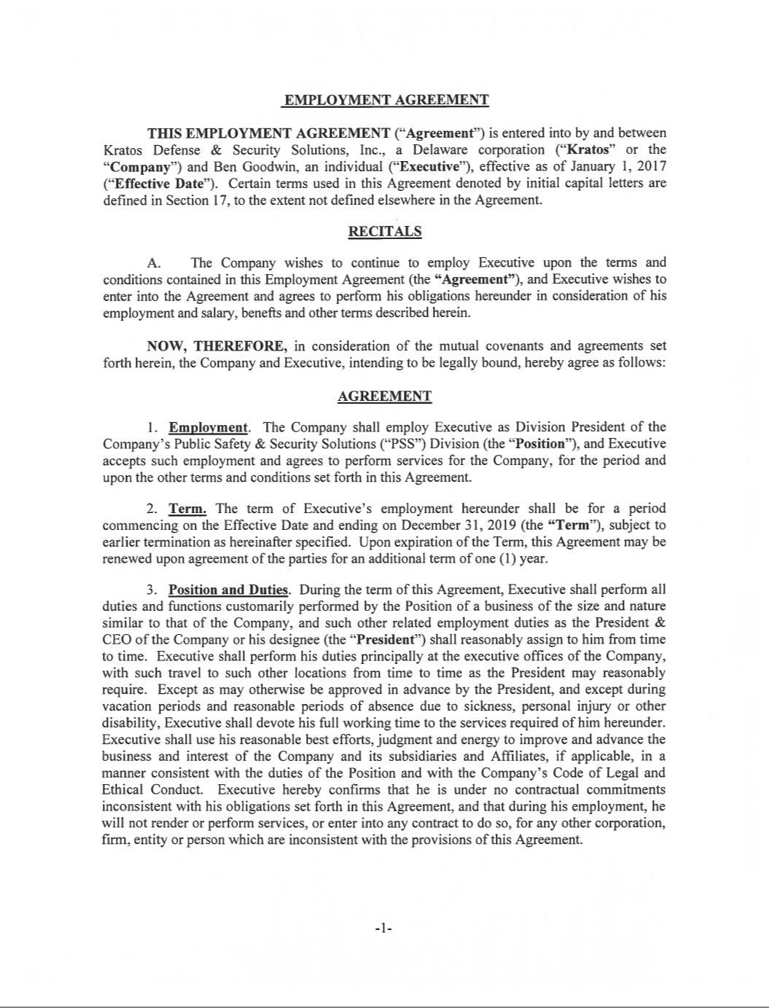

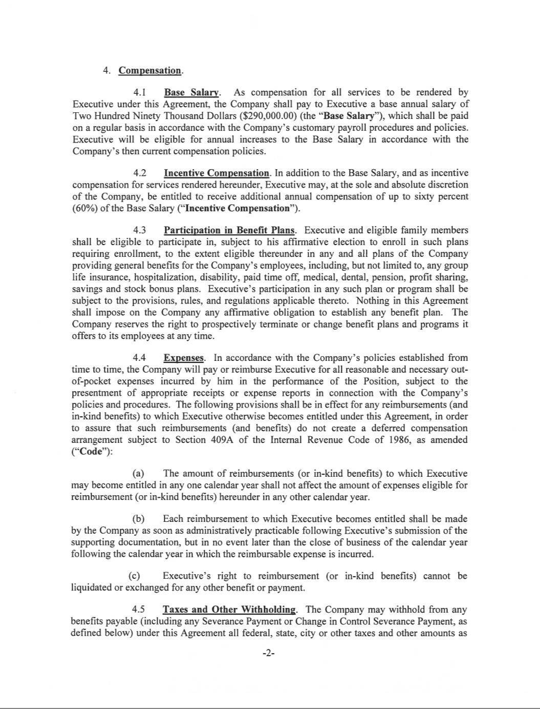

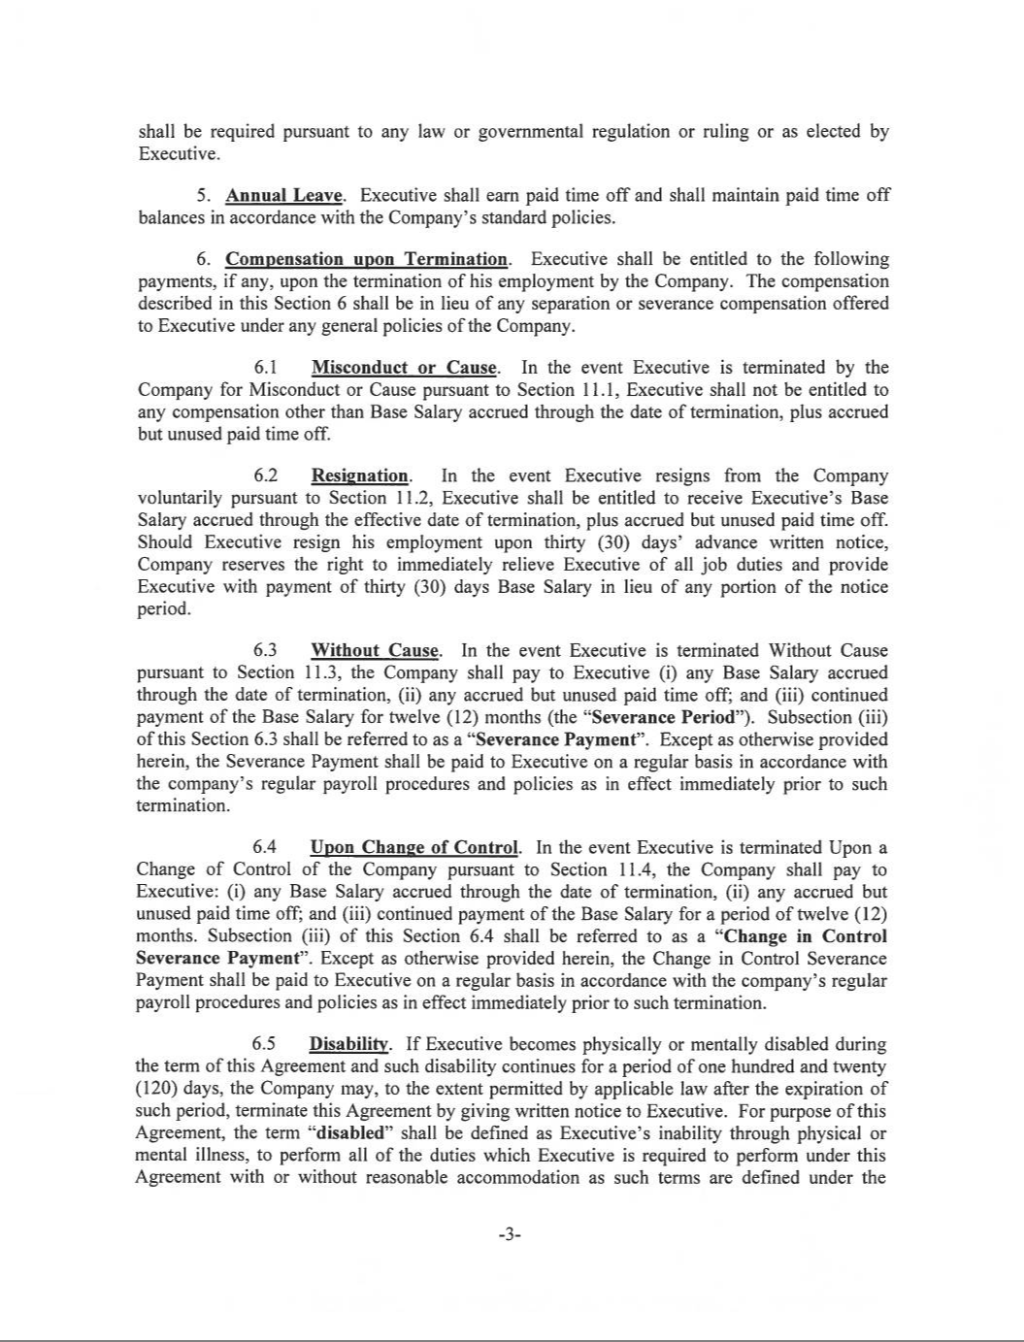

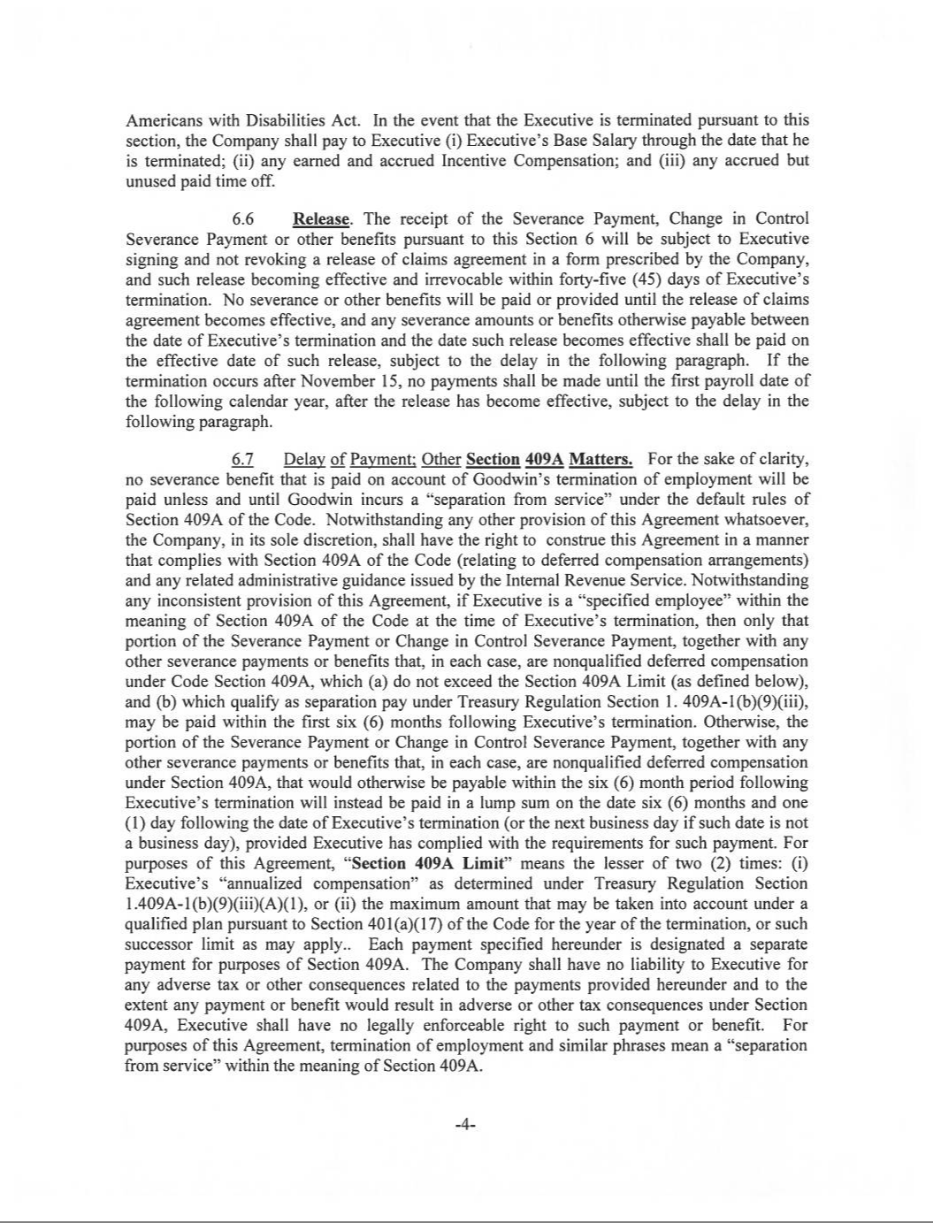

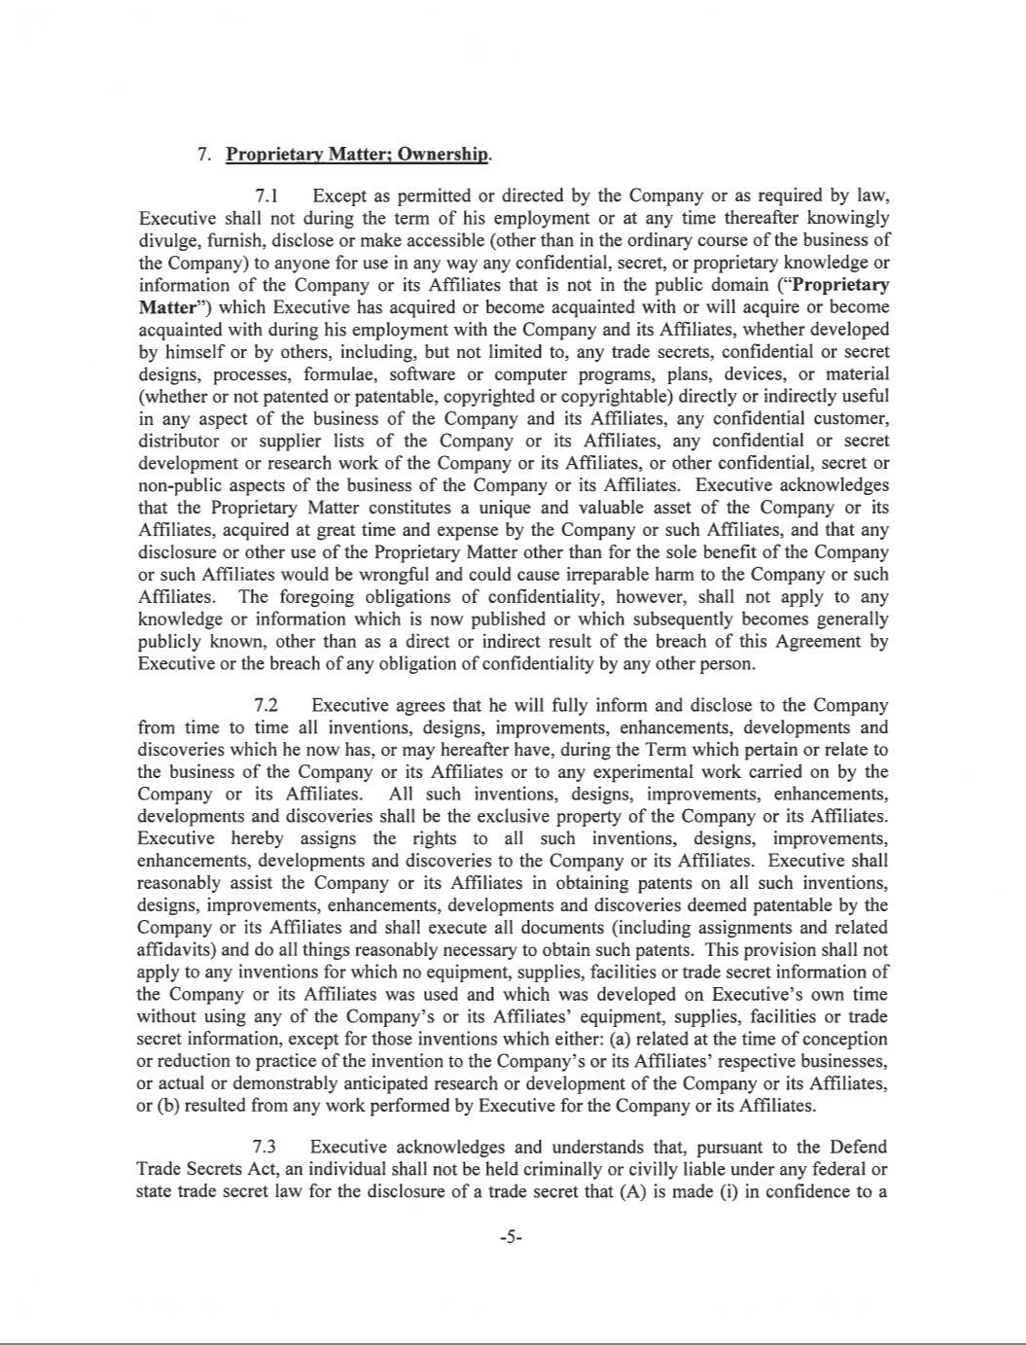

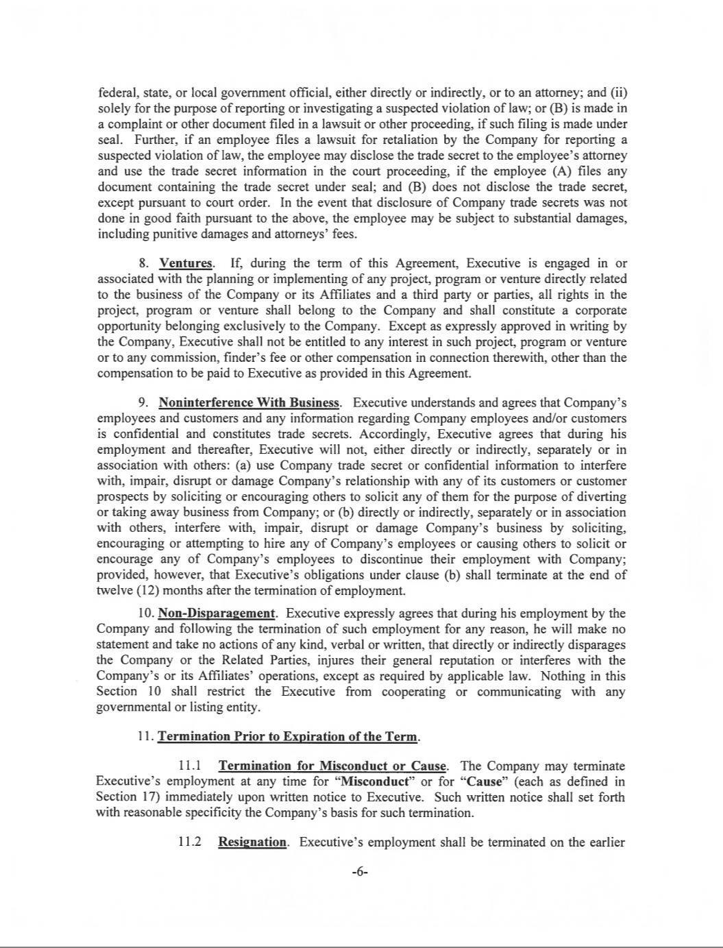

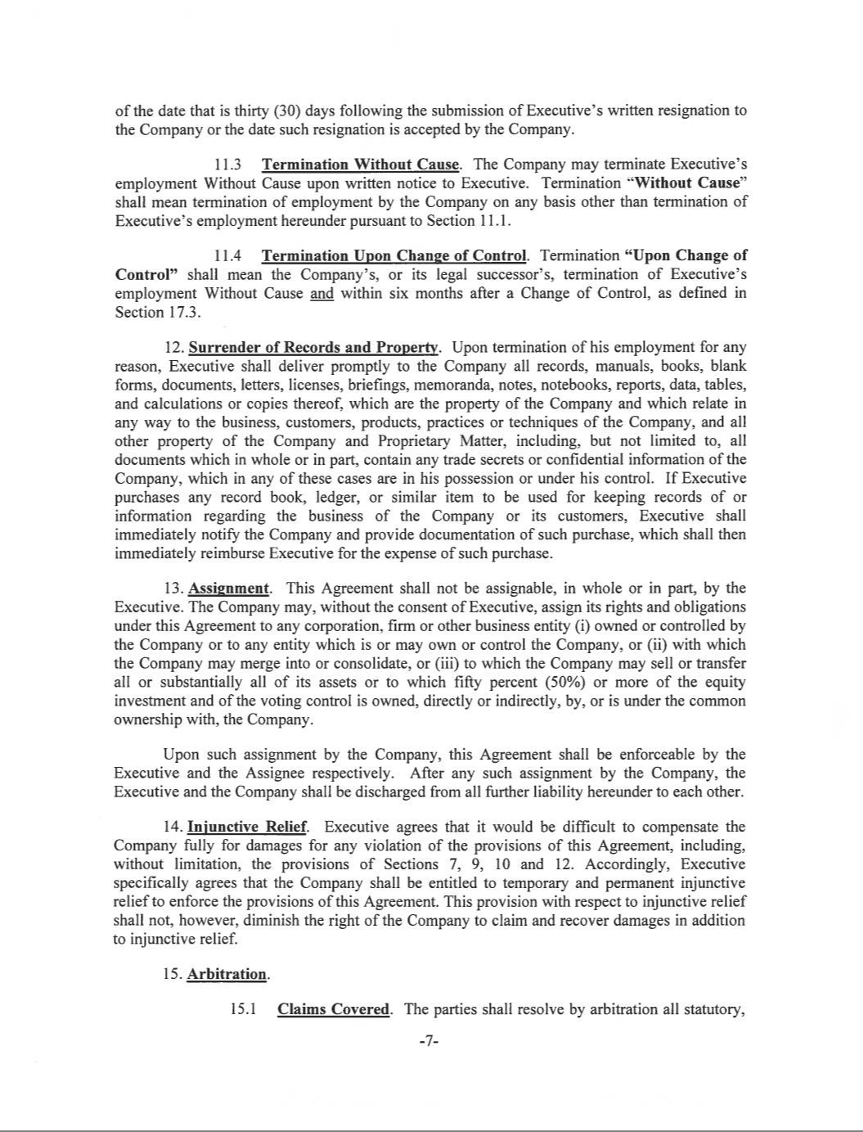

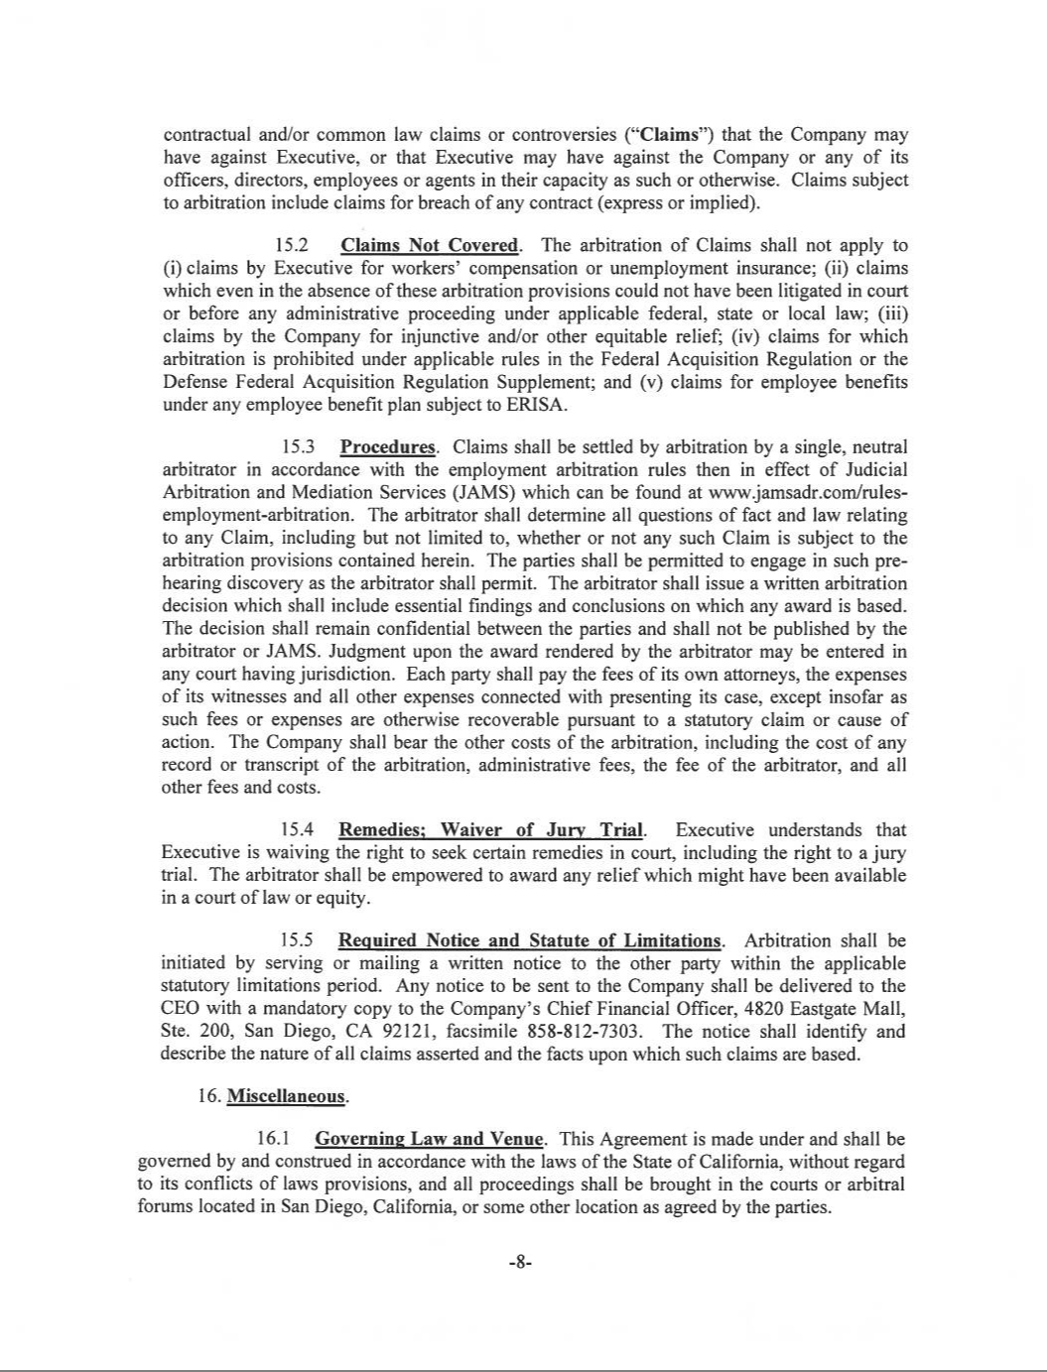

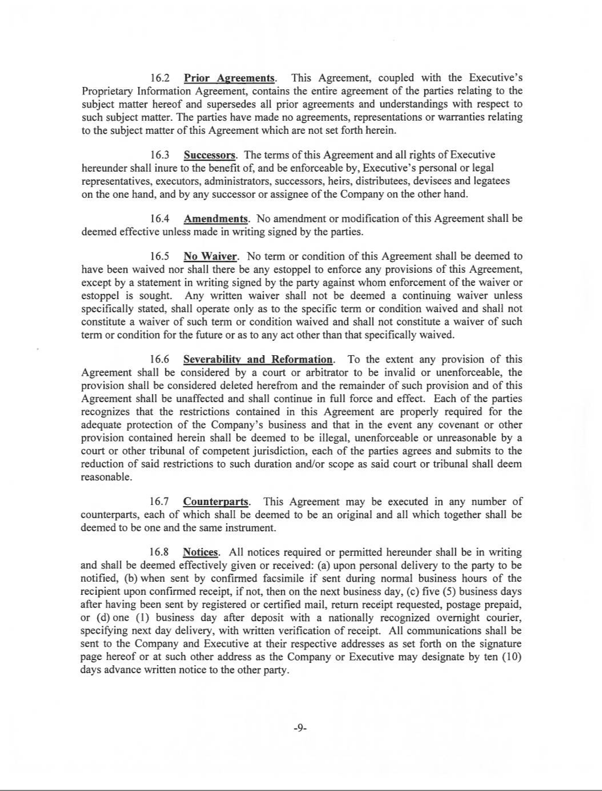

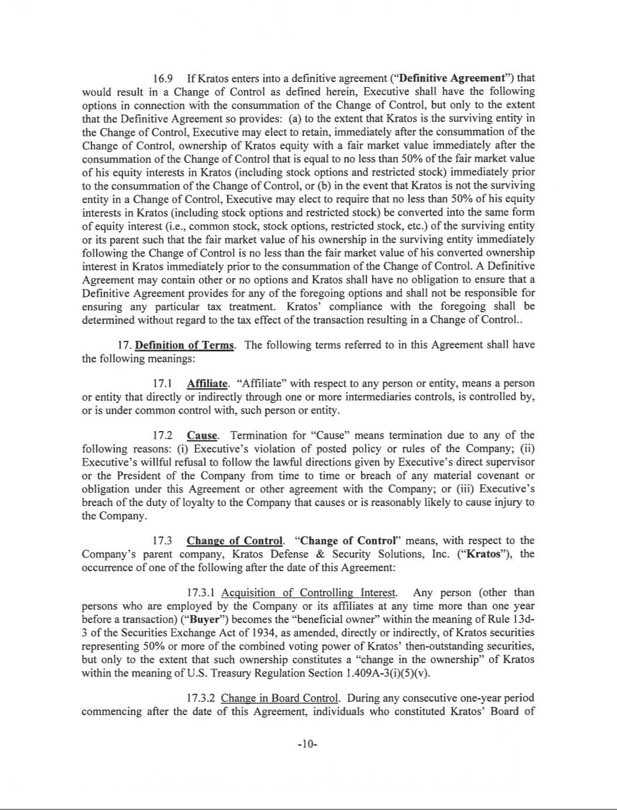

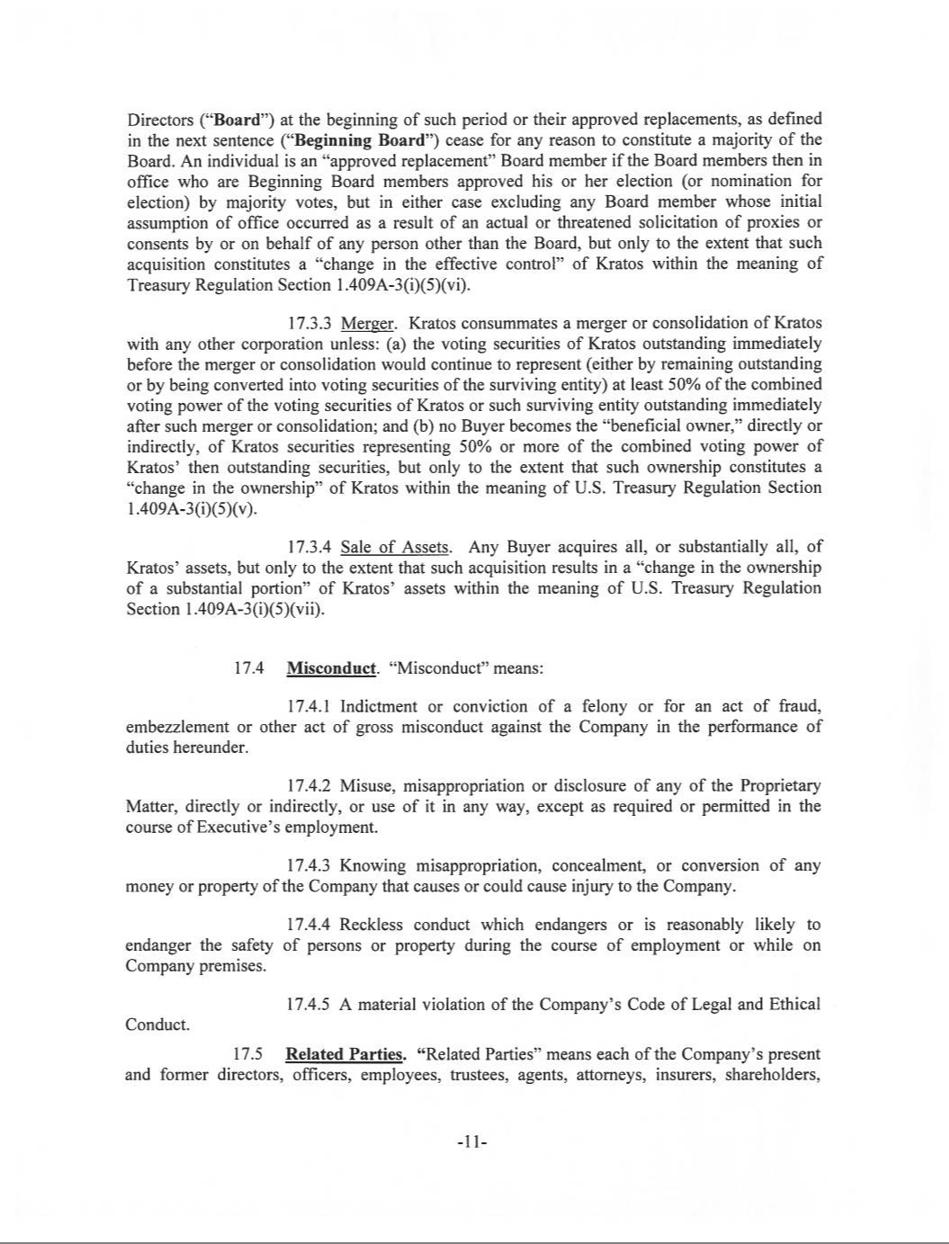

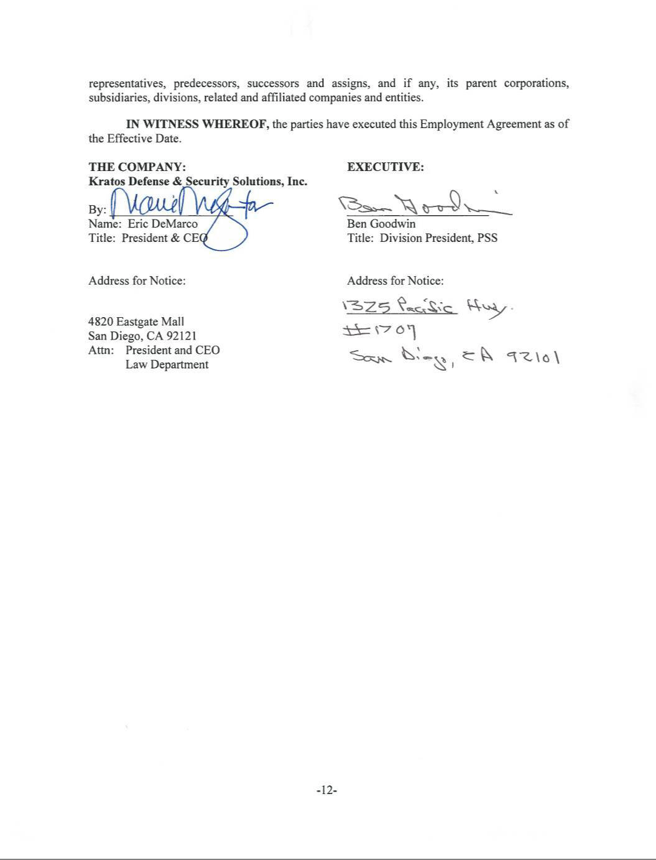

EXHIBIT 31.1

CERTIFICATION OF PRINCIPAL EXECUTIVE OFFICER

PURSUANT TO SECTION 302 OF THE SARBANES-OXLEY ACT OF 2002

I, Eric M. DeMarco, certify that:

- I have reviewed this quarterly report on Form 10-Q of Kratos Defense & Security Solutions, Inc.;

- Based on my knowledge, this report does not contain any untrue statement of a material fact or omit to state a material fact necessary to make the statements made, in light of the circumstances under which such statements were made, not misleading with respect to the period covered by this report;
- Based on my knowledge, the financial statements, and other financial information included in this report, fairly present in all material respects the financial condition, results of operations and cash flows of the registrant as of, and for, the periods presented in this report;
- The registrant’s other certifying officer(s) and I are responsible for establishing and maintaining disclosure controls and procedures (as defined in Exchange Act Rules 13a-15(e) and 15d-15(e)) and internal control over financial reporting (as defined in Exchange Act Rules 13a-15(f) and 15d-15(f)) for the registrant and have:

  - Designed such disclosure controls and procedures, or caused such disclosure controls and procedures to be designed under our supervision, to ensure that material information relating to the registrant, including its consolidated subsidiaries, is made known to us by others within those entities, particularly during the period in which this report is being prepared;
  - Designed such internal control over financial reporting, or caused such internal control over financial reporting to be designed under our supervision, to provide reasonable assurance regarding the reliability of financial reporting and the preparation of financial statements for external purposes in accordance with generally accepted accounting principles;
  - Evaluated the effectiveness of the registrant’s disclosure controls and procedures and presented in this report our conclusions about the effectiveness of the disclosure controls and procedures, as of the end of the period covered by this report based on such evaluation; and
  - Disclosed in this report any change in the registrant’s internal control over financial reporting that occurred during the registrant’s most recent fiscal quarter (the registrant’s fourth fiscal quarter in the case of an annual report) that has materially affected, or is reasonably likely to materially affect, the registrant’s internal control over financial reporting; and

- The registrant’s other certifying officer(s) and I have disclosed, based on our most recent evaluation of internal control over financial reporting, to the registrant’s auditors and the audit committee of the registrant’s board of directors (or persons performing the equivalent functions):

  - All significant deficiencies and material weaknesses in the design or operation of internal control over financial reporting which are reasonably likely to adversely affect the registrant’s ability to record, process, summarize and report financial information; and
  - Any fraud, whether or not material, that involves management or other employees who have a significant role in the registrant’s internal control over financial reporting.

Date: July 31, 2019

KRATOS DEFENSE & SECURITY SOLUTIONS, INC.

/s/ ERIC M. DEMARCO

Eric M. DeMarco

Chief Executive Officer, President

(Principal Executive Officer)

EXHIBIT 31.2

CERTIFICATION OF PRINCIPAL EXECUTIVE OFFICER

PURSUANT TO SECTION 302 OF THE SARBANES-OXLEY ACT OF 2002

I, Deanna H. Lund, certify that:

- I have reviewed this quarterly report on Form 10-Q of Kratos Defense & Security Solutions, Inc.;

- Based on my knowledge, this report does not contain any untrue statement of a material fact or omit to state a material fact necessary to make the statements made, in light of the circumstances under which such statements were made, not misleading with respect to the period covered by this report;

- Based on my knowledge, the financial statements, and other financial information included in this report, fairly present in all material respects the financial condition, results of operations and cash flows of the registrant as of, and for, the periods presented in this report;

- The registrant’s other certifying officer(s) and I are responsible for establishing and maintaining disclosure controls and procedures (as defined in Exchange Act Rules 13a-15(e) and 15d-15(e)) and internal control over financial reporting (as defined in Exchange Act Rules 13a-15(f) and 15d-15(f)) for the registrant and have:

  - Designed such disclosure controls and procedures, or caused such disclosure controls and procedures to be designed under our supervision, to ensure that material information relating to the registrant, including its consolidated subsidiaries, is made known to us by others within those entities, particularly during the period in which this report is being prepared;

  - Designed such internal control over financial reporting, or caused such internal control over financial reporting to be designed under our supervision, to provide reasonable assurance regarding the reliability of financial reporting and the preparation of financial statements for external purposes in accordance with generally accepted accounting principles;

  - Evaluated the effectiveness of the registrant’s disclosure controls and procedures and presented in this report our conclusions about the effectiveness of the disclosure controls and procedures, as of the end of the period covered by this report based on such evaluation; and

  - Disclosed in this report any change in the registrant’s internal control over financial reporting that occurred during the registrant’s most recent fiscal quarter (the registrant’s fourth fiscal quarter in the case of an annual report) that has materially affected, or is reasonably likely to materially affect, the registrant’s internal control over financial reporting; and

- The registrant’s other certifying officer(s) and I have disclosed, based on our most recent evaluation of internal control over financial reporting, to the registrant’s auditors and the audit committee of the registrant’s board of directors (or persons performing the equivalent functions):

  - All significant deficiencies and material weaknesses in the design or operation of internal control over financial reporting which are reasonably likely to adversely affect the registrant’s ability to record, process, summarize and report financial information; and

  - Any fraud, whether or not material, that involves management or other employees who have a significant role in the registrant’s internal control over financial reporting.

Date: July 31, 2019

KRATOS DEFENSE & SECURITY SOLUTIONS, INC.

/s/ DEANNA H. LUND

Deanna H. Lund

Executive Vice President, Chief Financial Officer

(Principal Financial Officer and Acting Principal Accounting Officer)

EXHIBIT 32.1

CERTIFICATION PURSUANT TO SECTION 906 OF THE SARBANES-OXLEY ACT OF 2002

(18 U.S.C. SECTION 1350)

In connection with the accompanying Quarterly Report of Kratos Defense & Security Solutions, Inc. (the “Company”) on Form 10-Q for the quarter ended June 30, 2019 (the “Report”), I, Eric M. DeMarco, Chief Executive Officer of the Company, certify, pursuant to 18 U.S.C. Section 1350, as adopted pursuant to Section 906 of the Sarbanes-Oxley Act of 2002, that:

- The Report fully complies with the requirements of Section 13(a) or 15(d) of the Securities Exchange Act of 1934, as amended; and

- The information contained in the Report fairly presents, in all material respects, the financial condition and results of operations of the Company.

Date: July 31, 2019

KRATOS DEFENSE & SECURITY SOLUTIONS, INC.

/s/ ERIC M. DEMARCO

Eric M. DeMarco

Chief Executive Officer, President

(Principal Executive Officer)

EXHIBIT 32.2

CERTIFICATION PURSUANT TO SECTION 906 OF THE SARBANES-OXLEY ACT OF 2002

(18 U.S.C. SECTION 1350)

In connection with the accompanying Quarterly Report of Kratos Defense & Security Solutions, Inc. (the “Company”) on Form 10-Q for the quarter ended June 30, 2019 (the “Report”), I, Deanna H. Lund, Chief Financial Officer of the Company, certify, pursuant to 18 U.S.C. Section 1350, as adopted pursuant to Section 906 of the Sarbanes-Oxley Act of 2002, that:

- The Report fully complies with the requirements of Section 13(a) or 15(d) of the Securities Exchange Act of 1934, as amended; and

- The information contained in the Report fairly presents, in all material respects, the financial condition and results of operations of the Company.

Date: July 31, 2019

KRATOS DEFENSE & SECURITY SOLUTIONS, INC.

/s/ DEANNA H. LUND

Deanna H. Lund

Executive Vice President, Chief Financial Officer

(Principal Financial Officer and Acting Principal Accounting Officer)

